**State of Idaho**

**Luma Project**

**Chart of Accounts Design**

**(Deliverable No**. **20)**

May 3, 2021



Document Control Information

Document Information

|  |  |
| --- | --- |
| Document Identification | DEL – 020 |
| Document Name | Chart of Accounts Design |
| Project Name | Luma |
| Client | State of Idaho, Office of the State Controller |
| Document Author | Brent Stigler |
| Document Version | 3.0 |
| Document Status | Final |
| Date Released | February 25, 2020 |
| File Name | Deliverable_020_Chart of Accounts Design_Final.docx |

Document Edit History

| Version | Date | Additions/Modifications | Prepared/Revised by |
| --- | --- | --- | --- |
| 1 | 2/25/2020 | Final | Brent Stigler |
| 2 | 12/7/2020 | Additional Changes Based on Two New Dimensions and New Order of Dimensions. | Tyler Odenath |
| 3 | 4/5/2021 | Minor revisions and formatting to living document. | Mason White |
|  |  |  |  |

Document Review/Approval History

| Date | Name | Organization/Title | Comments |
| --- | --- | --- | --- |
|  |  |  |  |
|  |  |  |  |
|  |  |  |  |

Distribution of Final Document

The following people are designated recipients of the final version of this document:

| Name | Organization/Title |
| --- | --- |
|  |  |
|  |  |
|  |  |

Table of Contents

1 Introduction 4

1.1 Deliverable Description 4

1.2 Purpose 4

1.3 Methodology Approach 4

1.4 Intended Use of Deliverable 4

2 Overview of the Chart of Accounts Development Process 6

2.1 COA Workgroup Charter 6

2.2 COA Redesign Timeline 6

2.3 COA Redesign Methodology 8

2.4 COA Redesign Review and Approval 10

3 Chart of Accounts Design 11

3.1 Agency 11

3.2 Project 12

3.3 Organizational Unit 13

3.4 Program 16

3.5 Appropriation 17

3.6 Fund 18

3.7 Account 20

3.8 Location 22

3.9 Additional Reporting 23

3.10 Trust Account 25

3.11 Funding Source 26

3.12 System Interagency 27

4 Appendix 29

4.1 Sample Statewide Crosswalks 29

4.2 Key Luma Terminology 32

4.3 Dimension Code Elements 33

# Introduction

## Deliverable Description

This Chart of Accounts (COA) Design deliverable document includes an introduction section describing the purpose, methodology approach, and intended use of this deliverable as specified in Deliverable Expectation Document (DED) 20, Chart of Accounts Design.

Following this introduction section is an Overview of the Chart of Accounts Development Process. The overview describes in greater detail the guiding principles of the Chart of Accounts Charter, the design timeline, the development methodology employed by the Luma Finance team, and reviews of the Chart of Accounts design work by oversight bodies.

Section 3 contains an in-depth discussion of each COA proposed dimension which includes the dimension definition (purpose), purpose rationale, structure, and structure rationale.

The document concludes with various appendices, including proposed COA accounting strings, sample crosswalks from the legacy Statewide Accounting and Reporting System (STARS) to the new COA design, and key Luma terminology as well as an at-a-glance grid summarizing the structural information contained in Section 3.

Refer to the PowerPoint presentation titled *Deliverable_020_Chart of Accounts Design Final_DEC2020.pptx* for additional information regarding the Luma COA design.

## Purpose

The purpose of this document, as stated in DED No. 20, is to define the new State of Idaho Chart of Accounts (the underlying financial and management reporting structure for Luma), provide high-level mapping to STARS, propose naming conventions, and set up a roadmap for transitioning to Luma.

## Methodology Approach

The methodology described in this deliverable provides the reader with a sense of the extensive work that went into the COA redesign process and sheds light on the discussions, considerations, and rationale that went into the final COA dimension structure. When relevant, the document includes details where decision points led to a COA Redesign Workgroup decision or software limitations drove an outcome.

## Intended Use of Deliverable

This deliverable provides reasonable assurance to decision-makers and stakeholders that the methodology employed by the COA Redesign Workgroup was sound and that adequate consideration was given to issues that may impact the State of Idaho and its ability to conduct business, meet the State’s reporting obligations, and provide meaningful information to internal and external stakeholders.

The intended audiences for this deliverable are:

* Project Management Office.
* Luma Functional Teams (Budget, Finance, Procurement, Human Resources, and Payroll).
* Luma Technical Team Leads (CSC).
* Division of Statewide Accounting.
* Fiscal Policy Advisory Committee.
* Luma Governance Board.
* State Financial Management Stakeholders.
* State Agencies Accounting and Fiscal Staff.

# Overview of the Chart of Accounts Development Process

## COA Workgroup Charter

**State of Idaho Chart of Accounts Redesign Project**

The State of Idaho, in preparation for the implementation of its next-generation ERP system (Luma) has chosen to redesign its Chart of Accounts (COA). Redesigning Idaho’s Chart of Accounts is one of the most strategically important actions the State will take in preparing the groundwork for Luma. The redesign of the Chart of Accounts will be based on leading practices in government and business. In addition, the new Chart of Accounts will be designed in advance of the implementation of Luma to help ensure that it, first and foremost, serves Idaho’s strategic purposes. Beginning the redesign of the COA before the implementation of the Luma system will help to make sure the implementation is completed in a timely manner.

Idaho’s Chart of Accounts redesign project seeks to:

* Emphasize simplicity, expandability, and flexibility for the life of the system.
* Manage operations and provide services to its citizens.
* Deliver a wide variety of financial and nonfinancial reporting.
* Capture financial data at a meaningful level of detail to assist agencies in managing financial resources.
* Meet the needs of both the State’s central control and operating agencies.

The approach that will be used to develop the new COA design for Idaho will include the following activities.

1. Chart of Accounts Redesign Workgroup - The workgroup will include individuals from multiple State agencies selected by the Luma Project Management Office (PMO) to participate in the workgroup.
2. Survey Key State Agencies - The survey will capture information about the State’s current COA and its actual use by agencies. It will include questions about “pain points” for agencies regarding the existing COA. If necessary, follow up interviews will be conducted with State agencies to gather additional insights about “pain points”.
3. Request Feedback from Selected Software Vendor and Integrator on COA Design Best Practices Present the software vendor and integrator with information provided by key State agencies and request feedback on the proposed COA design and its compatibility with their products.
4. Develop COA Governance Model and Maintenance Process - A new COA governance model and maintenance process will be developed and reviewed by the Luma Governance Board. COA review considerations include: standardization, consistency of use across agencies, alignment with industry best practices, and flexibility to meet agency requirements.
5. Develop Final COA Design Report - The final COA design report will present the redesigned COA structural elements and governance approach proposed by the State. Additionally, it will include an overview of the rationale of the COA development.

## COA Redesign Timeline

Timeline Overview: 2014 to July 2019

In 2014, recognizing the risks associated with Idaho’s aging business systems, the State of Idaho, Office of the State Controller (SCO) embarked on a journey to replace its legacy Employee Information System (EIS) and Statewide Accounting and Reporting System (STARS), with a new system known as Luma. Over the next five years, through an extensive competitive bidding process, the State selected Information Services Group (ISG) to serve in an advisory role to the State, Infor CloudSuite as its Enterprise Resource Planning (ERP) software solution, Deloitte Consulting LLP as its software integration vendor, and Sherpa as the budgeting module.

COA Redesign Workgroup Timeline: August 1, 2019 to February 12, 2020

The SCO assembled a team of State employees representing a diverse cross-section of agencies to drive the COA redesign process, the backbone of Luma. This group was named the COA Redesign Workgroup. Between August 2019 and February 2020, the COA Redesign Workgroup met nine times as part of the COA redesign process. Key activities were as follows:

* Kick-off meeting.
  + August 1, 2019.
* Five workshops between November and December 2019. Led by Deloitte, these workshops sought to identify the dimensions of the COA necessary for the State of Idaho to conduct business, to meet its internal and external reporting requirements, and to provide meaningful tracking of financial and non-financial information. Workshops were held on the following dates:
  + November 6, 2019.
  + November 12, 2019.
  + November 19, 2019.
  + November 22, 2019.
  + December 3, 2019.
* One formal presentation to the COA Redesign Workgroup on the proposed COA dimension structure was held on January 16, 2020.
* Two follow-up meetings with the COA Redesign Workgroup were held on the following dates:
  + January 24, 2020.
* February 12, 2020.

The COA Redesign Workgroup comprised representation from the following State agencies:

* Division of Financial Management (DFM).
* Legislative Services Office.
* Office of the State Controller.
* Department of Health and Welfare.
* Department of Transportation.
* State Tax Commission.
* Department of Labor.
* Department of Commerce.
* State Liquor Division.
* Military Division.
* Department of Fish and Game.
* Idaho State Police.
* Department of Correction.
* Department of Juvenile Corrections.
* Department of Lands.
* Correctional Industries.

Luma Finance Team Timeline: August 1, 2019 to February 12, 2020

In addition to the above COA Redesign Workgroup meetings, the Luma Finance team (a subset of the work group assigned to the Luma project full-time) performed additional tasks, assignments, and meetings to advance COA elements development. The Luma Finance team met numerous times between August 1, 2019 and February 12, 2020 to further discuss and define the requirements for the COA redesign.

The Luma Finance Team presented the proposed COA redesign work to the Luma Governance Board on January 28, 2020 with positive feedback.

Luma Finance Team Timeline: February 12, 2020 to December 7, 2020

From February to December, the Luma Project Team built and implemented the new Chart of Accounts to use in testing. During this testing phase, the Luma team determined that in order to maximize the full functionality and efficiency of the Chart of Accounts, the following additional actions would need to be taken:

* Two (2) new dimensions would need to be added to the original ten (10) Luma Chart of Account dimensions.
* The Chart of Accounts dimension order would need to be revised to fully capitalize on structure relation functionality within Luma.

## COA Redesign Methodology

The Luma Finance team took a multifaceted approach to the COA redesign. Tackling this task from several directions ensured that the Luma Finance team considered not just the State financial reporting impact of the new COA design but also factored in budgetary needs, external/third-party reporting and oversight, end-user and operational considerations, cash management controls, Idaho state statutes, and change impacts. The methodology employed included high-level, policy-focused discussions as well as practical operational exercises. The following is a brief discussion of each of those considerations.

Budgetary Needs

The Idaho legislature appropriates spending authority to State agencies based on a number of factors: program/organizational structure, object (i.e. standard class) and fund. In order to meet these needs, the Luma Finance team incorporated the necessary elements into the COA dimension structure required for State appropriation bill drafting. The COA Redesign Workgroup identified system needs of the new Sherpa budgeting system which will replace the existing budgeting system currently employed by DFM.

External/Third-party Reporting and Oversight

Over one-third of Idaho’s state agencies receive federal funds, which come with external financial and performance reporting requirements. The Luma Finance team incorporated these external reporting requirements into the design elements to provide agencies with the flexibility to meet these obligations. An extra dimension, called ‘Additional Reporting’, was added to allow agencies to track information not currently captured through the State’s financial reporting requirements. The team also considered indirect cost allocation requirements and project set-up needs for these agencies.

End-user and Operational Considerations

The COA dimension order (the order of the dimensions in the GL string) is embedded with intelligence aimed to reduce keystrokes and data entry errors. The Luma Finance team and the COA Redesign Workgroup arrived at an initial keying order based on operational behaviors common to agencies participating in the COA Redesign Workgroup. Luma allows users to set up structure relations, pairing of COA elements, and defaulting downstream dimension values to reduce or eliminate data entry options and errors. The Luma Finance team and COA Redesign Workgroup both agreed that the Project dimension would drive more coding decisions than any other dimension, thus driving the decision to make project information second in the keying order (after the Agency dimension). Dimensions keyed less often or never, due to limited use or defaulting, were placed at the end of the dimension order.

Following the testing phase described above in the COA design timeline, the Luma Finance team further revised the keying order of the COA dimensions to arrive at the order presented in this deliverable. This is discussed in further detail at the end of this section.

Cash Management Controls

Effective cash management, separate from appropriation control, is a high priority for the State of Idaho. In order to meet the control requirements of the State, the Luma Finance team considered multiple options for achieving the objectives of responsible cash management. One hurdle the Finance team had to overcome was the issue of at what level in the fund hierarchy cash needed to be controlled. Some agencies require cash controls at the subfund posting level (see Section 3 below for further explanation of hierarchical structures), while others require cash controls at a summary level. System functionality requires that cash control is placed at the posting level within Luma. After extensive discussion with Infor representatives, a programming solution was implemented that meets the needs of the State and resolves this issue. This solution allows the state to control cash at the posting level or at a summary level, grouping multiple subfunds under a summary fund for cumulative cash controls.

State Statutes

Discussions surrounding the development of the Organizational Unit dimension focused on Idaho Code Section 67-2402, which drives the organizational structure of the executive branch of Idaho State government (which encompasses most State agencies that will use the new system to meet their financial reporting, human resources and payroll, procurement, and budgetary needs). In order to align agency set-up in the Organizational Unit dimension with Idaho Code Section 67-2402, while providing adequate flexibility to account for agencies that do not perfectly align with the stated structure, the Finance team decided on a hierarchy structure based on Section 67-2402, with additional optional levels for agencies that require them.

Change Impacts

The Luma Finance team examined current use of the STARS system including fields and data elements to ensure current agency needs and system uses were incorporated into or accounted for in the new COA design. The Finance team was careful to suggest changes in numbering or naming only when it made sense (either to accommodate new Luma requirements or to fix system limitations/issues stemming from the legacy STARS system). For example, the team elected to carry forward agency numbers and budget unit coding from the legacy STARS system. However, to overcome the confusion between budget (spending plan) and state appropriation (spending authority), the team elected to change the naming of the dimension housing this information from Budget Unit to Appropriation.

The Finance team discussed current assumptions and how Luma would control spending against appropriation. For example, some agencies’ appropriated programs closely align with their organizational structure while others do not. On the assumption that the Idaho legislature would continue with current funding models into the future, the team elected to set up a separate dimension for appropriation to allow agencies the flexibility to default the appropriation from the Program, Project, or Organizational Unit dimension codes created by the agency. This allows agencies maximum flexibility to design their coding to meet their operation needs while also achieving the necessary controls based on legislative directive.

Operational Exercises for Dimension Development

While the COA Redesign Workgroup meetings involved mainly high-level, policy-driven discussions aimed at meeting reporting and statutory requirements, the Luma Finance team focused in on the practical application of the new COA design. The Luma Finance team completed entity-specific exercises to build out agency values in each proposed COA dimension. These exercises helped to further discussion about dimension structure internally as well as with the COA Redesign Workgroup. Through these exercises, the team identified additional information necessary to achieve the State’s operational, reporting, and tracking objectives.

Changes Resulting from Luma Testing

Two new dimensions were added to the original COA design at the end of the System Integration 1 testing phase. The first additional dimension is the Trust Account dimension and the second is the System Interagency dimension.

The Trust Account dimension was added to the Luma Chart of Accounts upon recommendation from the Infor Software Development team. Initially, the project team identified the ‘Project’ dimension as the preferred method to track trust account information. However, after further testing and additional requirements gathering, the State of Idaho identified the need for tracking trust accounts by using a dimension set aside for this sole purpose. The Infor Software Development team intends to release a solution in the application to meet the needs of the state in November of 2021, five months after Idaho’s go-live date. In order to meet the interim needs of state agencies, the state is adding this dimension to house minimal Trust Account data.

The creation of the System Interagency dimension resulted from testing of the interagency billing functionality in Luma. In order to trace transactions between agencies, the team determined that adding a new dimension would provide necessary transparency at the transaction level. Without this dimension, agencies would only be able to view the half of a two-sided transaction that impacts their agency. They would not have transparency into which agency is on the other side of a two-sided transaction between agencies (interagency fund transfers, interagency billings, etc.) since state agencies are generally prevented from viewing the transactional data of other agencies.

The order of the Chart of Accounts dimensions is driven mainly by structure relations and the need for budgetary control. The team determined that grouping the dimensions strategically would benefit both structure relations and enhance budgetary control. Changes to the order of the now twelve (12) dimensions resulted in the following COA dimension order: Agency, Project, Organizational Unit, Program, Appropriation, Fund, Account, Location, Additional Reporting, Trust Account, Funding Source, and System Interagency.

## COA Redesign Review and Approval

The COA design has gone through and will continue to go through an extensive vetting process to ensure the COA redesign meets the needs of the State of Idaho and its discrete components. The COA design was informally agreed to by the Luma Finance team. It was presented to the COA Redesign Workgroup on January 16, 2020, revised further, and re-presented on January 24, 2020. The Luma Finance team presented a proposed design to the Luma Governance Board on January 28, 2020 and presented a draft version of this deliverable to the Luma Project PMO February 12, 2020. The COA redesign proposal was presented to the Governance Board for concurrence on February 25, 2020. The Luma Project Manager acting on behalf of the State Controller completed a review and accepted the deliverable on February 25, 2020. Further changes to the COA design were presented to the Governance Board on December 15, 2020, and to the Project Manager acting on behalf of the State Controller on___________.

# Chart of Accounts Design

Section 3 provides detailed information about each Chart of Accounts dimension including the purpose, rationale, and default hierarchy description with key information about the dimension format (keying order, posting level, field length, etc.) following.

## Agency

Dimension Purpose and Usage

Purpose Definition *Used to identify the state agency.*

Purpose Rationale Within Luma, all financial activity is accounted for by individual State agency and then aggregated for statewide financial reporting. The Agency dimension is critical in allowing the State to post and group transactions by state agency. This practice is supported by Idaho Code Titles 1 and 67 which provide for the establishment and structure of the three branches of State government and their further subdivision, comprised of approximately 83 state agencies that will conduct transactions in Luma.

Dimension Format

Format Definitions

Keying Order Placed first in dimension order.

Summary Level There are no summary levels.

Posting Level **Agency**. Required. This dimension has only one level, the posting level, which is a unique 3-digit code used to identify the agency. Centrally managed.

Number of Levels One.

Field Length Min Minimum 3 characters: Agency code (INTEGER, 3). Determined by the State Controller’s Office (SCO). Centrally managed.

Field Length Max Maximum 3 characters: Agency code (INTEGER, 3). Determined by the State Controller’s Office (SCO). Centrally managed.

Format Rationale

Keying Order For most agencies, this field will not be keyed, but rather defaulted based on user login identification number. The Agency dimension is a parent to the Organizational Unit dimension and, therefore, precedes the Organizational Unit dimension in keying order for those agencies that may key transactions for multiple state agencies.

Posting Level There is only one level within the hierarchy. Both reporting and posting happen at the posting level.

Number of Levels/

Number of Children The Agency dimension has a flat hierarchy. There are no additional levels.

The COA Redesign Workgroup contemplated adding a summary level above the agency posting level within the hierarchy of this dimension. The summary level would include the three branches (executive, judicial, and legislative) of State government. The purpose of adding a summary level would be to facilitate reporting by the three branches of State government. Due to system limitations within Luma, it is not possible to add hierarchies in this dimension. The workgroup determined that functionality within the application to group State agencies for aggregated reporting would suffice.

Field Length Min/Max The COA Redesign Workgroup contemplated the optimal numbering format for this dimension, discussing the pros and cons of deviating from the 3-digit agency codes used in the legacy STARS system. Using a 2-digit code would limit the system to 89 possible codes (10-99), as the system will not easily accommodate a leading zero. Using 3 digits increases that limit to 899 (100-999). The Finance team determined the need for more than 900 agency codes is highly improbable and did not see a compelling reason to depart from the numbers currently assigned to state agencies.

## Project

Dimension Purpose and Usage

Purpose Definition *Used to capture transactional data on agency-specific activities or efforts usually with a planned end date.*

*May also be used to silo financial activity into a discrete ledger to simplify reconciliation and record-keeping. For example: cost allocation pools, ongoing billings to outside entities for work performed, co-location and rental agreements, etc.*

Purpose Rationale The Project dimension is a powerful tool that can be used by agencies to meet their mission. In order to take full advantage of the functionality of the system, the COA Redesign Workgroup has elected to define the purpose of this dimension broadly to meet a variety of operational needs across agencies throughout the State. The purpose has been expanded well beyond the traditional “project” (building, capital, software, etc.), and includes a variety of examples to help agencies understand the broad spectrum of uses for which this dimension may be applied.

Dimension Format

Format Definitions

Keying Order Placed second in dimension order.

Summary Level 1 **Project Level 1**.Required. The highest summary level within the Project dimension. Agency level.

Summary Level 2+ **Project Level 2+**.Optional. The summary level within the Project dimension determined by the agency. Agencies may want to use Summary Level 2+ to group projects by project type. Further granularity through hierarchy build-out to be determined by agency on a project by project basis, based on operational necessity.

Posting Level Lowest level of hierarchy. Required if a project is set up. Determined by agency, based on operational necessity.

Number of Levels Unlimited. Determined by agency, based on set-up needs.

Number of Children Unlimited. Determined by agency, based on set-up needs.

Field Length Min Minimum 3 characters: Summary level 1 - Agency code (INTEGER, 3).

Field Length Max Maximum 25 characters: Subsequent levels - Agency code (INTEGER, 3) plus (ALPHANUMERIC, 22). Determined by agency, based on set-up needs.

Format Rationale

Keying Order Luma allows for downstream pairing and defaulting when keying transactions. By placing the Project dimension second in the keying order, just after the Agency dimension, agencies can pair or default one or more downstream dimensions to reduce or eliminate unnecessary keying. This will increase efficiency and reduce errors.

Summary Level 1 Agency level. Centrally-managed summary level but agencies control the description.

Summary Level 2+ Agencies manage additional levels to build out the Project dimension to meet their needs. Agencies may find it useful to group projects by type or category in order to maintain a system of organization. While some projects will be relatively flat (cost pools, for example), other projects may have complex set-ups to track project costs by phase, task, or activity.

Posting Level Reporting may be done at any level within a hierarchy but posting occurs only at the lowest level of any hierarchy within Luma.

Number of Levels/

Number of Children Unlimited number of “children” can be created from one “parent” within any level of a project hierarchy. Luma allows users to add unlimited levels within a hierarchy and to create an unlimited number of children from a parent, providing maximum flexibility to agencies to structure their projects as deep and as broad as needed to achieve operational, reporting, and billing needs.

Field Length Min/Max In order to give agencies maximum flexibility in their numbering conventions for projects, while also avoiding the risk of using a project code already in use by another agency, all codes at all levels in the project dimension will start with the 3-digit agency code. In the STARS legacy system, the maximum cumulative number of characters available to agencies in the Grant and Grant Phase or Project Number and Project Phase fields is 8 alphanumeric. The Luma limitation for this dimension is 25 characters. Luma Finance Team discussions led to the conclusion that some agencies may need up to the system max of 25 characters to meet their mission.

## Organizational Unit

Dimension Purpose and Usage

Purpose Definition *Used to Identify cost center and its place in an agency’s organizational structure.*

Purpose Rationale Organizational structure and associated accounting activity are integral parts of State of Idaho financial reporting and tracking. Idaho Code 67-2402 provides for the internal structure for each department of the Executive branch of Idaho State government. For many of these departments, appropriation aligns with organizational structure. Additionally, for these departments, internal spending controls are placed at various levels of the organization, creating the necessity for this dimension from an appropriation standpoint as well as an internal budgeting and cost control perspective.

Dimension Format

Format Definitions

Keying Order Placed third in dimension order.

Summary Level 1 **Entity**. Required level. Centrally-managed.

Summary Level 2 **Division**. Required level.

Summary Level 3 **Bureau**. Required level. If the division does not have further subdivision, this will be a direct roll-up to Division from level below.

Summary Level 4 **Section**. Required level. If the bureau does not have further subdivision, this will be a direct roll-up to Bureau from the level below.

Summary Level 5+ Further subdivision of sections. Optional, as required by agency structure.

Posting Level **Cost Center**. Required. Posting level cost centers may fall anywhere from level 4 or lower, based on number of intermediate levels required by agency hierarchical structure.

In order to accommodate the need for a default cost center for asset conversion, each agency will be set up with a cost center 99999. This cost center sits outside the hierarchical structure described above and is a child of the agency.

Number of Levels Minimum 5 (Entity, Division, Bureau, Section, Cost Center); max unlimited. Dependent upon agency organizational structure.

Number of Children Unlimited. Dependent upon agency organizational structure.

Field Length Min Entity 9 characters (ALPHANUMERIC, 9), Division minimum 1 character (INTEGER, 1), Bureau minimum 2 characters (INTEGER, 2), Section minimum 3 characters (INTEGER, 3), Cost Center minimum 3 characters (INTEGER, 3).

Field Length Max Maximum 15 characters (INTEGER, 15).

Format Rationale

Keying Order Luma allows for downstream pairing and defaulting when keying transactions. By placing the Organizational Unit dimension third in the keying order, agencies will have the ability to pair or default downstream dimension values to their Organizational Unit codes. This will reduce or eliminate unnecessary keying, increase efficiency, and reduce data entry errors.

Placed third in keying order, right after the Project dimension, as the posting level cost center may be inferred by the project keyed. If not, then keying a cost center may determine another downstream field through pairing, such as appropriation.

Summary Level 1 Entity is the highest level of this dimension. This is needed for allocations to function properly in Luma and aids structure relation setup.

Summary Level 2 Per Idaho Code 67-2402, Division is the second highest level of Executive branch agency internal structures. For many agencies, this ties directly to their annual state appropriation.

Summary Level 3 Per Idaho Code 67-2402, Bureau is the third highest level of executive branch agency internal structures. Bureaus are a further subdivision of Divisions. For some agencies, this ties directly to their annual state appropriation.

Summary Level 4 Per Idaho Code 67-2402, Section is the fourth highest level of Executive branch agency internal structures. Sections are further subdivisions of Bureaus. For some agencies, this may tie directly to their annual state appropriation.

Summary Level 5+ Some agencies may require further subdivision in their organizational structure below Section due to the size and depth of their organization. Allowing for flexibility in Organizational Unit dimension hierarchies below the Section level gives agencies the ability to build out their structures in this dimension. This allows agencies to meet their cost tracking and reporting needs, rather than forcing all agencies into a “one-size fits all” structure.

Posting Level Cost center is the lowest level in the Organizational Unit dimension for all agencies. This builds consistency across all agencies, creates a common vernacular, and encourages consistent reporting within the agency and across agencies.

Agencies may apply roll-up logic to Cost Center numbering (all codes in Division 1 start with 1, including the cost center numbers). Omitting roll-up logic to cost center numbering enables agency reorganizations at the lowest level without having to renumber cost centers in order to maintain cost center numbering patterns.

Number of Levels A minimum of five levels (Entity, Division, Bureau, Section, Cost Center), with an unlimited maximum, maintains compliance and observance of Idaho state statute while providing the flexibility to add additional levels as needed based on agency operational necessity.

Number of Children Unlimited. Based on agency organizational structure.

Field Length Min Minimum 9 (ALPHANUMERIC, 9) at Entity level. Minimum 1 (NUMERIC, 1) with each level typically adding a place to facilitate roll-up logic in numbering. Cost Center has a minimum of three places (INTEGER, 3).

Field Length Max Luma limits field length to 15 (INTEGER, 15).

## Program

Dimension Purpose and Usage

Purpose Definition *Used to identify ongoing agency activities or functions that occur across the organizational structure.*

Purpose Rationale The Program dimension provides agencies with the ability to define each of their major programs or functions and track financial activity accordingly. For agencies where their appropriated programs do not align with their organizational structure, this dimension may be used to pair with the Appropriation dimension to put coding in place to provide proper spending controls, especially if an agency desires the ability to track or control program costs at a more granular level than just Appropriation.

Dimension Format

Format Definitions

Keying Order Placed fourth in dimension order.

Summary Level 1 **Program Level 1**. Required. The highest summary level within the Program dimension. Agency level. Centrally-managed.

Summary Level 2+ **Program Level 2+**. Optional. The second highest summary level within the Program dimension. Agencies may create summary levels to facilitate operational and reporting needs.

Posting Level Lowest level of hierarchy. Determined by agency based on setup needs.

Number of Levels Unlimited. Determined by agency based on set-up needs.

Number of Children Unlimited. Determined by agency based on set-up needs.

Field Length Min Minimum 3 characters: Summary level 1 - Agency code (INTEGER, 3).

Field Length Max Maximum 15 characters: Agency code (INTEGER, 3) plus (ALPHANUMERIC,12). Determined by agency based on set-up needs.

Format Rationale

Keying Order Luma allows for downstream pairing and defaulting when keying transactions. By placing the Program dimension fourth in the keying order, agencies will have the ability to pair or default downstream dimension values to their Program codes. This will reduce or eliminate unnecessary keying, increase efficiency, and reduce data entry errors.

Summary Level 1 Agency level. Centrally-managed summary level but agencies control the description.

Summary Level 2+ Agencies manage additional levels to build out the Program dimension to fit their mission. Agencies may find it useful to group programs by type or category in order to maintain a system of organization.

Posting Level Reporting may be done at any level within a hierarchy but posting occurs only at the lowest level of any hierarchy within the Luma application. Posting level will depend on program structure and reporting needs of the agency.

Number of Levels/

Number of Children An unlimited number of “children” can be created from one “parent” within any level of a program hierarchy. The ability to add unlimited levels within a hierarchy and to create an unlimited number of children from a parent provides users with maximum flexibility to structure Program dimension hierarchies as deep and as broad as needed to achieve operational and reporting needs.

Field Length Min/Max In order to give agencies maximum flexibility in their numbering conventions for their programs, while also avoiding the risk of using a program code already in use by another agency, all codes at all levels in the Program dimension will start with the 3-digit agency code.

In the legacy STARS system, there are 6 fields dedicated to Program tracking: function, activity, program, element, Program Cost Account (PCA), and PCA level 1. Some agencies use the fields redundantly, and some use a field for a purpose better suited for another field (location, for example). Through well-designed Program dimension hierarchies in conjunction with other dimensions, agency code plus up to 12 alphanumeric places should give agencies flexibility to meet their reporting requirements.

## Appropriation[1]

Dimension Purpose and Usage

Purpose Definition *Used to identify a program or segment of an agency for which the legislature has set spending controls. Agency appropriations align with specific state goals and performance objectives.*

Purpose Rationale Stand-alone dimension that can be paired with or defaulted from the Project, Organizational Unit or Program dimension to set appropriation and spending controls for agencies based on their annual appropriation bill.

Dimension Format

Format Definitions

Keying Order Placed fifth in dimension order.

Summary Level 1 **State Goal**.Required. Centrally-managed.

Summary Level 2 **State Objective**.Required. Centrally-managed.

Posting Level **Appropriation**.Required. Centrally-managed.

Number of Levels 3 levels.

Number of Children Many.

Field Length Min/Max State Goal (INTEGER, 2); State Objective (INTEGER, 2); Appropriation (ALPHA, 4).

Format Rationale

Keying Order Placed in the middle of the keying order, as appropriation will typically be defaulted from or paired with an upstream dimension value. The dimension will be used to drive appropriation control in the Fund and Account dimensions through pairing and defaulting. Staff will rarely need to manually enter an appropriation if defaulting from the Project, Organizational Unit, or Program dimension.

Summary Level 1 State Goal is used in statewide reporting.

Summary Level 2 State Objective is used in statewide reporting.

Posting Level Appropriation code ties directly to State appropriation as set by the legislature. Used to exert spending limits by program or organizational structure, fund, and account type (specifically expenditure types).

Number of Levels/

Number of Children Determined by SCO/DFM to meet financial and performance reporting needs.

Field Length Min/Max Coding determined by SCO/DFM.

## Fund[2]

Dimension Purpose and Usage

Purpose Definition *Used to identify the accounting entity against which a transaction is recorded.*

Purpose Rationale A fund is an accounting entity with a self-balancing set of accounts. Cash and/or other resources together with all related liabilities, obligations, reserves, and equities are recorded in funds. Thus, a fund segregates the monies of the entity according to legal or purpose restrictions. The Idaho Legislature appropriates by Fund or Subfund to meet certain objectives in accordance with laws, special regulations, restrictions, or limitations. Statewide Comprehensive Annual Financial Reports (CAFR) are organized by fund type, fund subtype, and fund.

Luma uses the Fund dimension when posting financial transactions to check cash balance for payment processing. Cash balance (or unused line of credit balances) must be in excess of the payment amount processed in order to proceed, as this is an indication of sufficient cash to cover the expenditure.

Dimension Format

Format Definitions

Keying Order Placed sixth in dimension order.

Summary Level 1 **Fund Type** (governmental, proprietary, and fiduciary). Determined by and set-up through COA governance process).

Summary Level 2 **Fund Subtype** (general fund, special revenue fund, enterprise fund, internal service fund, investment fund, pension fund, etc.). Determined by and set-up through COA governance process.

Summary Level 3 **Fund**.Determined by and set-up through COA governance process.

Posting Level **Subfund**. Determined by and set-up through COA governance process.

Number of Levels 4 levels within this dimension.

Number of Children Unlimited. Determined by and set-up through COA governance process.

Field Length Min/Max: Summary Level 1 - *Fund Type* (ALPHA, 1). Governmental: G, Proprietary: P, Fiduciary: F, Non CAFR Reporting: N.

Summary Level 2 - *Fund Subtype* (ALPHA, 3). Governmental: GEN (General Fund), GIE (Income Funds), Proprietary: IGI (Group Insurance Acct), IRM (Retained Risk Acct), Fiduciary: FAC (Custodial Funds), FAP (Payroll Clearing). This is not the comprehensive list of Summary Level 2 Fund Subtypes but rather a small sample of each.

Summary Level 3 - *Fund* (INTEGER, 3), no leading zeroes.

Posting Level 4 - *Subfund* (INTEGER, 5). Fund + (INTEGER, 2).

Subfund numbering will generally be based on legacy STARS numbering, with the following modifications: the first leading zero will be dropped, funds with more than one leading zero will be renumbered, and funds with no Subfund will be succeeded by ‘00’, as follows:

|  |  |  |
| --- | --- | --- |
| **Fund (Legacy STARS System)** | **Fund Detail (Legacy STARS System)** | **Subfund (Luma Application)** |
| 0348 | 02 | 34802* |
| 0401 | No fund detail | 40100 |
| 0050 | 03 | 10503 |
| 0001 | No fund detail | 10000 |

*For SCO and CAFR reporting purposes, Fund and Subfund will be preceded by a leading one when the Fund pertains to an outside entity (non-State agency). For example: 134802 instead of 34802.

Format Rationale

Keying Order Luma allows for downstream pairing and defaulting when keying transactions. By placing the Fund dimension sixth in the keying order, agencies will be able to pair or default one or more downstream dimension values to reduce or eliminate unnecessary keying, increase efficiency, and reduce errors.

Summary Level 1 CAFR reporting is done at the Fund Type level. Decision to build Fund Type into the Default hierarchy was made to facilitate CAFR reporting requirements.

Summary Level 2 CAFR reporting is done at the Fund Subtype level. Decision to build Fund Subtype into the Default hierarchy was made to facilitate CAFR reporting requirements.

Summary Level 3 Fund: Summary level created to group and organize the hierarchy.

Posting Level Subfund: The Idaho Legislature may appropriate to agencies at the Subfund level. Reporting may be done at any level within a hierarchy but posting occurs at the lowest level of any hierarchy within the Luma application.

Exceptions to the number of levels may exist due to agency-specific requirements for bucket funds. These exceptions will be managed according to COA Governance procedures.

Number of Levels/

Number of Children There are 4 levels to the Fund dimension. Summary levels 1 and 2 (Fund Type and Fund Subtype) are dictated by Governmental Accounting Standards Board (GASB) requirements for CAFR reporting. Summary level 3 (Fund) and the posting level (Subfund) may have an unlimited number of “children” based on the needs of the State, as determined by SCO/DFM in conjunction with Idaho state statute.

Field Length Min/Max The COA Redesign Workgroup initially determined there was no compelling reason to make sweeping changes to the fund numbering system in the legacy STARS system.

The decision to drop the leading 0 (zero) on the fund number was prompted by the Infor Spreadsheet Designer (ISD) functionality in Luma, an Excel commercial add-on used to upload and download large datasets to and from Luma. Excel drops leading zeros unless the cell is formatted as text. Fund and Subfund (legacy STARS Fund and Fund Detail) were combined at the posting level to create unique posting codes for each Subfund. Since each dimension only has one keying field, both legacy STARS Fund and Fund Detail are required in one entry.

## Account

Dimension Purpose and Usage

Purpose Definition *Used to capture the category of all transactions that affect the balance sheet, statement of revenues, expenditures, and changes in fund balance, and other financial statements.*

Purpose Rationale Comprehensive, uniform system of accounts that incorporates industry-standard guidelines for consistent reporting.

Dimension Format

Format Definitions

Keying Order Luma allows for downstream pairing and defaulting when keying transactions. By placing the Account dimension seventh in the keying order, agencies will have the ability to pair or default Account codes with upstream dimension values. This will reduce or eliminate unnecessary keying, increase efficiency, and reduce data entry errors.

Summary Level 1 **Account Type**.[3] Assets, Liabilities, Fund Balance, Revenues, Expenditures[4], System Accounts (Infor Sys Acct), Deferred Inflows (Def Inflows), Deferred Outflows (Def Outflow), Statistics. Centrally managed.

Summary Level 2 **Account Category**.Further breakdown of Account Types (for example assets: current, non-current; liabilities: long-term, other; expenditures: personnel costs, operating expenditures, capital outlay, and trustee and benefit payments). Centrally managed.

Summary Level 3 **Summary Account**.Further breakdown of Account Category (for example personnel: salary, benefits; operating: communications, professional services). Centrally managed.

Summary Level 4 **Account**.Additional detail for Summary Accounts (for example salary: employees, student, shift differential). Centrally managed.

Posting Level **Posting Account**.For many accounts the Account level (Summary Level 4) and the Posting Account level are the same. Posting Account may be a further breakdown of an Account, where additional detail is required. Centrally managed.

Number of Levels 5 levels. Determined by SCO to meet CAFR and other State reporting requirements, in conjunction with the reporting requirements of State agencies.

Number of Children As needed for standardization. To be determined by SCO to meet CAFR and other State reporting requirements, in conjunction with the reporting requirements of State agencies.

Field Length Min/Max Account type, account category and summary account (ALPHANUMERIC 15), account (INTEGER, 4), posting account (INTEGER, 6), all determined by SCO.

Format Rationale

Keying Order Required field that will need to be keyed in most instances. Placed after other dimensions that may pair with the Account dimension to limit available posting selections. For example, a project may be paired with the Account dimension to allow only personnel or operating expenditure types.

Summary Level 1 Account Type. Highest level of account groupings to allow more detailed breakout of account types to be organized into a logical order.

Summary Level 2 Account Category. Critical grouping level necessary for financial reporting and appropriation spending controls.

Summary Level 3 Summary Account. Additional detail for tracking spending and to add transparency in cost types. Another critical level of account grouping for financial reporting.

Summary Level 4 Account. Typical account breakdown used in tracking expenditures, revenues, assets, and liabilities by more specific name to provide end users with adequate descriptions to pick the correct account so that proper financial reporting occurs.

Posting Level Posting Account. In many cases, posting level and Summary Level 4 are the same. In cases where agencies require more detail than provided by summary level 4, multiple posting level posting accounts will roll up to an account. Agencies that require this additional detail for external reporting and tracking purposes can employ the COA data governance process to request additional posting accounts for a given account.

Number of Levels/

Number of Children Determined by SCO. Five levels are adequate to provide the various levels of detail needed for effective financial reporting while providing agencies with the level of detail necessary to meet their agency-specific reporting requirements. Accounts needed in this dimension are driven by financial and external/third-party reporting requirements.

Field Length Min/Max[5] Naming and numbering convention determined by SCO. Posting level of 6 characters was deemed most efficient to allow the State enough positions to number all necessary posting accounts while grouping them into a logical numbering system that mirrors other public and private accounting structures.

## Location

Dimension Purpose and Usage

Purpose Definition *Used to record transactions to a specific geographic position.*

Purpose Rationale The Location dimension exists to capture location information on a transactional level. A location may be an office or building, a city, county, other jurisdiction, or other physical location.

Dimension Format

Format Definitions

Keying Order Placed eighth in dimension order.

Summary Level 1 **Location Level 1**. Required. The highest summary level within the Location dimension. Agency level. Centrally-managed.

Summary Level 2+ **Location Level 2+**. Optional. The second highest summary level within the Location dimension. Agencies may create summary levels to facilitate operational and reporting needs.

Posting Level **Location**.Lowest level of hierarchy.

Number of Levels Unlimited.

Number of Children Unlimited.

Field Length Min Minimum 3 characters: Agency code (INTEGER, 3).

Field Length Max Maximum 15 characters: Agency code (INTEGER, 3) plus (ALPHANUMERIC, 12). Determined by agency based on set-up needs.

Format Rationale

Keying Order Placed lower in the keying sequence as not all agencies will make use of the dimension. For the agencies that do, not all transactions may require a location.

Summary Level 1 Agency level. Centrally-managed summary level but agencies control the description.

Summary Level 2+ Agencies that elect to utilize the Location dimension may build hierarchies that meet their mission.

Posting Level Agencies that elect to utilize the Location dimension may build hierarchies that meet their mission. There is no preset level for the posting level in this hierarchy.

Number of Levels/

Number of Children Agencies that elect to utilize the Location dimension may build hierarchies that meet their mission.

Field Length Min/Max In order to give agencies maximum flexibility in their numbering conventions for their locations, while also avoiding the risk of using a location code already in use by another agency, all codes at all levels in the Location dimension will start with the 3-digit agency code.

## Additional Reporting

Dimension Purpose and Usage

Purpose Definition *Used to code and track financial transactions based on agency-specific needs.*

Purpose Rationale This dimension is optional and can be used for agency-specific reporting and tracking requirements on activities that may cross several projects, programs, appropriations, organizational units, or locations.

Dimension Format

Format Definitions

Keying Order Placed ninth in dimension order.

Summary Level 1 **Additional Reporting Level 1**. Required. The highest summary level within the Additional Reporting dimension. Agency level. Centrally-managed.

Summary Level 2+ **Additional Reporting Level 2+**. Optional. The second highest summary level within the Additional Reporting dimension. Agencies may create summary levels to facilitate operational and reporting needs.

Posting Level Lowest level of hierarchy. Posting happens at the lowest level of any hierarchy within Luma.

Number of Levels Unlimited. To be determined at the agency level based on agency needs.

Number of Children Unlimited. To be determined at the agency level based on

agency needs.

Field Length Min Minimum 3 characters: Agency code (INTEGER, 3). Determined by agency based on set-up needs.

Field Length Max Maximum 15 characters: Agency code (INTEGER, 3) plus (ALPHANUMERIC, 12). Determined by agency based on set-up needs.

Format Rationale

Keying Order Not all agencies will employ the use of the Additional Reporting dimension. For those that do, additional reporting may be triggered by an upstream keying event in one of the other dimensions. Luma allows for downstream pairing and defaulting when keying transactions. By placing the Additional Reporting dimension in the ninth position, agencies will be able to use this dimension for agency specific activity tracking and reporting with “upstream” dimensions.

Summary Level 1 Agency level. Centrally-managed summary level but agencies control the description.

Summary Level 2+ To be determined at the agency level based on operational needs. Summary levels within the Additional Reporting dimension are optional. If not needed, agencies can set up a posting level item with no additional hierarchical roll-up.

Posting Level Reporting may be done at any level within a hierarchy but posting happens at the lowest level of any hierarchy within the Luma application.

Number of Levels/

Number of Children Unlimited number of “children” can be created from one “parent” within any level of the Additional Reporting hierarchy. The ability to add unlimited levels within a hierarchy and to create an unlimited number of children from a parent provides maximum flexibility to agencies to structure the Additional Reporting dimension as deep and as broad as needed to achieve operational, reporting, and transactional needs.

Field Length Min/Max In order to give agencies maximum flexibility in their numbering conventions for their additional reporting elements, while also avoiding the risk of using an additional reporting code already in use by another agency, all codes at all levels in the Additional Reporting dimension will start with the 3-digit agency code.

## Trust Account[6]

Dimension Purpose and Usage

Purpose Definition *Used to record assets held in trust or in a custodial capacity by an agency to allow them to manage and distribute trustee fund balances.*

Purpose Rationale The Trust Account dimension is an interim solution to manage asset balances held in individual trust accounts. The future disposition of this dimension will depend on development of the long-term solution.

Dimension Format

Format Definitions

Keying Order Placed tenth in Dimension order.

Summary Level 1 **Trust Account Level 1**. Required if agency manages trust accounts within Luma. The highest summary level within the Trust Account dimension. Agency level. Centrally-managed.

Summary Level 2+ **Trust Account Level 2+**. Optional. The second highest summary level within the Trust Account dimension. Agencies may create summary levels to facilitate operational and reporting needs.

Posting Level Lowest level of hierarchy. Posting happens at the lowest level of any hierarchy within Luma.

Number of Levels There are 2+ levels to the Trust Account dimension.

Number of Children Unlimited. Determined by agency based on set-up needs.

Field Length Min Minimum 3 characters: Agency code (INTEGER, 3). Centrally-managed.

Field Length Max Maximum 15 characters: Agency code (INTEGER, 3) plus (ALPHANUMERIC, 12). Determined by agency based on set-up needs.

Format Rationale

Keying Order The Trust Account Dimension was placed at the end of the series of dimension values that could be potentially hand keyed by an agency. Use of this dimension will be limited to a small number of agencies.

Summary Level 1 Agency level. Centrally-managed summary level but agencies control the description.

Summary Level 2+ Agencies may create summary levels within the Trust Account dimension to group data and facilitate reporting.

Posting Level Lowest level of the hierarchy.

Number of Levels/

Number of Children Unlimited number of “children” can be created from one “parent” within any level of the Trust Account hierarchy. The ability to add unlimited levels within a hierarchy and to create an unlimited number of children from a parent provides maximum flexibility to agencies to structure the Trust Account dimension as deep and as broad as needed to achieve operational, reporting, and transactional needs.

Field Length Min/Max In order to give agencies maximum flexibility in their numbering conventions for their trust accounts, while avoiding the risk of using a trust account code already in use by another agency, all codes at all levels in the Trust Account dimension will start with the 3-digit agency code.

## Funding Source

Dimension Purpose and Usage

Purpose Definition *Used in conjunction with the Project dimension to indicate the source of the money used to fund a project. This could include federal, state, local grants, outside entities billed for a service or project, private grants, etc.*

Purpose Rationale The Funding Source dimension provides agencies with the ability to connect a project to its associated source of funding. This allows agencies to produce invoices for billing purposes and to summarize transactional data by funding source in order to meet reporting requirements. Use of the Funding Source dimension triggers additional functionality in the system to produce the underlying accounting transactions associated with the billing and receipting of funds in association with a project.

Dimension Format

Format Definitions

Keying Order Placed eleventh in Dimension order.

Summary Level 1 **Funding Source Level 1**. Required. The highest summary level within the Funding Source dimension. Agency level. Centrally-managed.

Summary Level 2+ **Funding Source Level 2+**. Optional. The second highest summary level within the Funding Source dimension. Agencies may create summary levels to facilitate operational and reporting needs.

Posting Level Lowest level of hierarchy. Posting happens at the lowest level of any hierarchy within Luma.

Number of Levels Unlimited. To be determined at the agency level based on needs.

Number of Children Unlimited. Determined by agency based on set-up needs.

Field Length Min Minimum 3 characters: Agency code (INTEGER, 3).

Field Length Max Maximum 15 characters: Agency code (INTEGER, 3) plus (ALPHANUMERIC, 12). Determined by agency based on set-up needs.

Format Rationale

Keying Order A funding source will always have one or more projects linked to it. This dimension will not be keyed but is derived from business rules established in the project contract setup. Since this dimension will never be a keyed value, it was placed after all of the potentially keyed dimensions in the Chart of Accounts dimension order.

Summary Level 1 Agency level. Centrally-managed summary level but agencies control the description.

Summary Level 2+ To be determined at the agency level based on operational needs. Summary levels within the Funding Source dimension are optional.

Posting Level Lowest level of hierarchy. Posting happens at the lowest level of any hierarchy within Luma. This will be defaulted off of the Project linked to the Funding Source. This field will never be keyed by an end-user.

Number of Levels/

Number of Children Unlimited number of “children” can be created from one “parent” within any level of the Funding Source hierarchy. The ability to add unlimited levels within a hierarchy and to create an unlimited number of children from a parent provides maximum flexibility to agencies to structure the Funding Source dimension as deep and as broad as needed to achieve operational, reporting, and transactional needs.

Field Length Min/Max In order to give agencies maximum flexibility in their numbering conventions for their funding sources, while also avoiding the risk of using a Funding Source code already in use by another agency, all codes at all levels in the Funding Source dimension will start with the 3-digit agency code.

## System Interagency

Dimension Purpose and Usage

Purpose Definition *Allows agencies to trace the source and destination of accounting entries between agencies.*

Purpose Rationale The System Interagency dimension provides transparency on transactions between two agencies. Without this field, agencies would be unable to trace the source of a transaction originating from another agency, unless agency staff had access to the other agency’s data in Luma.

Dimension Format

Format Definitions

Keying Order Placed twelfth (last) in Dimension order.

Summary Level 1 All agencies – statewide. Required. Centrally-managed.

Posting Level **Agency**. Unique 3-digit code used to identify the agency. Mirrors the Agency dimension. Required. Centrally-managed.

Number of Levels There are two levels to this dimension.

Number of Children Will be equal to the number of agencies.

Field Length Min Minimum 3 characters (ALPHANUMERIC, 3).

Field Length Max Maximum 3 characters (ALPHANUMERIC, 3).

Format Rationale

Keying Order Placed last as agencies will never key values into this dimension. System-generated.

Summary Level 1 Required summary level. Centrally-managed.

Posting Level Using agency number provides all state agencies with the ability to easily identify and trace the transaction to the other agency involved in two-sided transactions between agencies.

Number of Levels/

Number of Children Two levels. Summary and posting levels. There is no need to build a more complex hierarchy for this dimension. No reporting or other benefit would be derived.

Field Length Min/Max There are 3 digits in the posting level; will correspond to agency numbers for easy and universal identification of agencies involved in the transaction.

# Appendix

## Sample Statewide Crosswalks

Agency Dimension

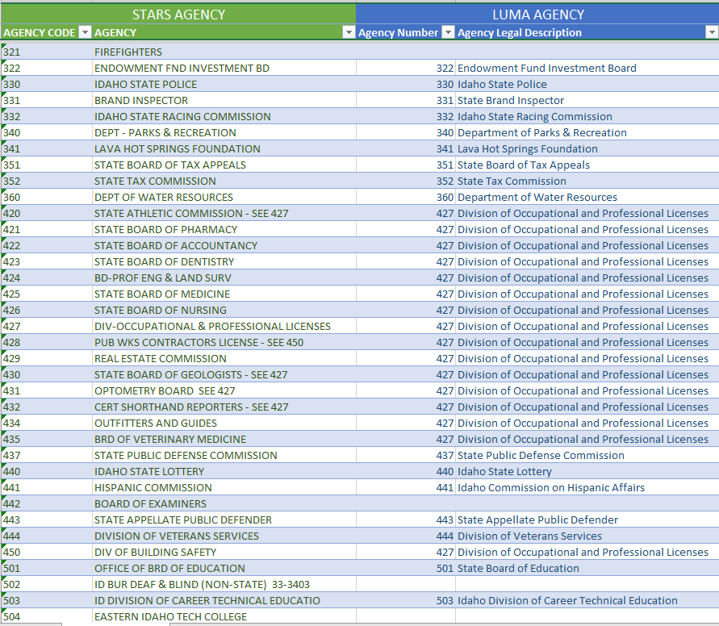

Appropriation Dimension

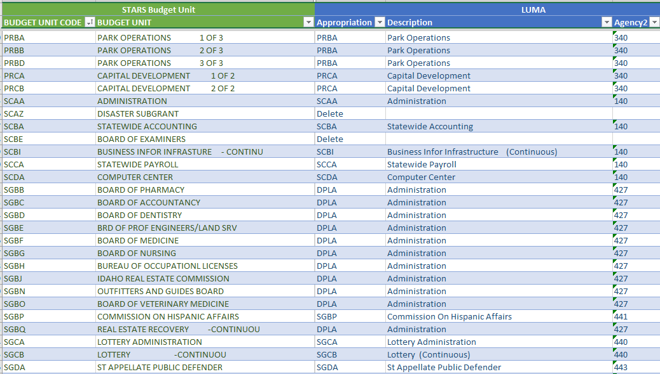

Fund Dimension

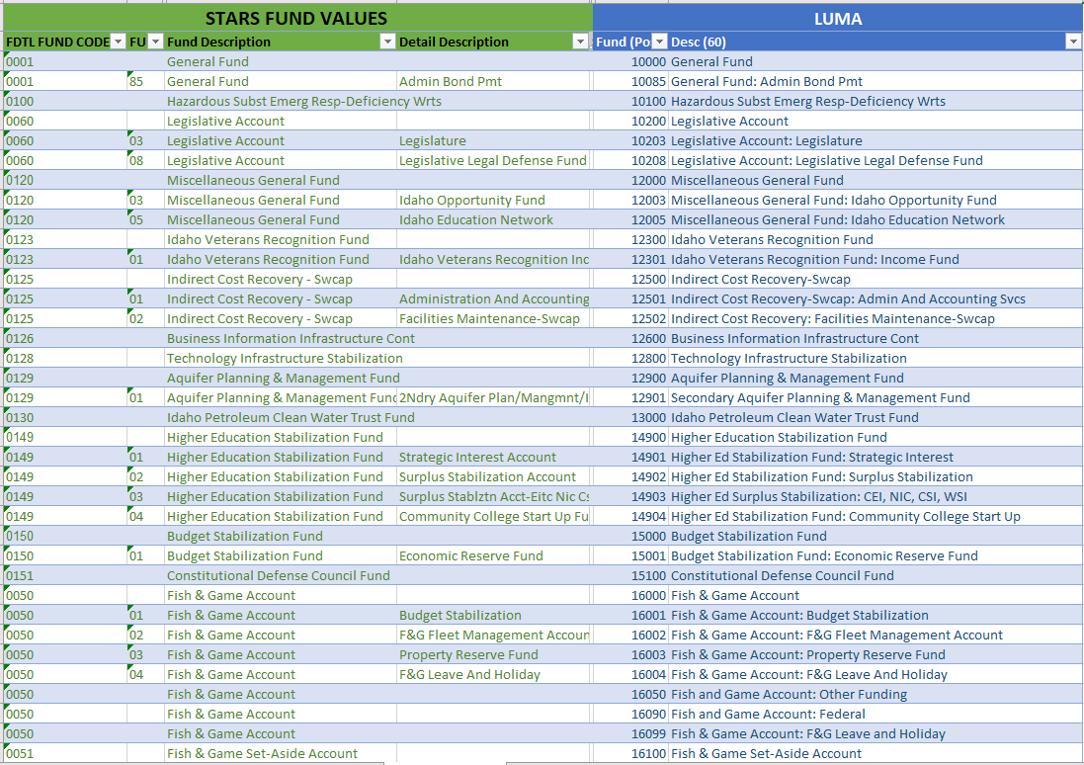

Account Dimension – Revenues and Expenditures

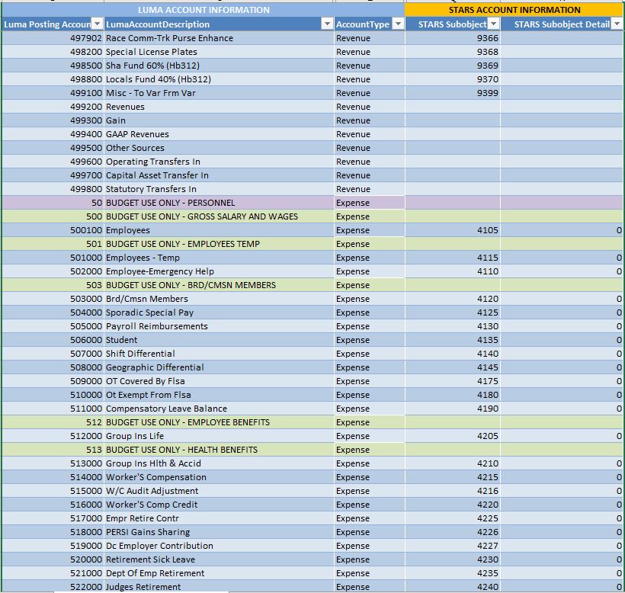

Account Dimension – Assets and Liabilities

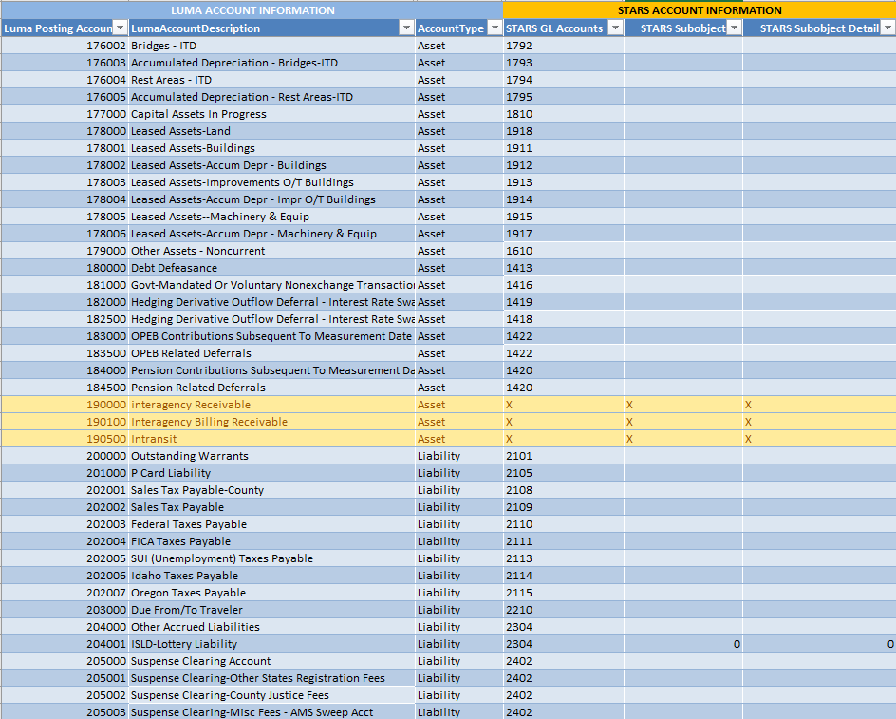

## Key Luma Terminology

| **Term** | **Definition** |
| --- | --- |
| **Chart of Accounts** | A Chart of Accounts (COA) is used by an organization to define each class of items for which funds are spent or received. It is the basic and the most important building block for any finance organization. A well-designed COA increases business value, enhances internal controls, reduces costs, increases efficiency, and improves customer service. |
| **Dimension** | A dimension represents a “bucket” of values available to represent and record each accounting entry. Effective segmentation allows for ease in addressing reporting needs. |
| **Hierarchy** | The hierarchy is the roll-up structure upon which the Chart of Accounts is framed. Typically, a hierarchy consists of a singular entity at the top with subsequent entities underneath. |
| **Ledgers** | All transactions are associated with a ledger. Ledgers can be shared across the reporting basis, except the close ledger and currency ledger that are unique to each reporting basis. The core ledger is created automatically and assigned to the reporting basis. A close ledger is generated automatically for each reporting basis that is created. The ability exists to define other ledgers to meet an organization's reporting requirements. For example, an organization can create adjustment ledgers and eliminating entries ledgers. Ledgers participate in a basis and can be shared by multiple bases. An organization can create an unlimited number of ledgers (for example, budgetary, tax, localized, audit, and operational adjustments). |
| **Reporting Basis** | Pulls together the accounting elements required to produce financial reports that adhere to specific accounting standards (such as Generally Accepted Accounting Principles (GAAP) and GASB). A reporting basis can also be used to generate internal financial reports that are used by executives to make budgetary, management, and operational assessments. Reports must be in context of a reporting basis to guarantee complete results. The delivered reports within Luma include the reporting basis definition by using a cross reference to the reporting basis dimension found in the Luma Finance Enterprise Group (FEG) cube. FEG includes attributes from the business classes Finance Enterprise Group and Reporting Basis. |
| **Structure Relations** | Create a relationship between dimensions of the Finance Enterprise Group finance structure. Structure relations can be used to define validation rules for each relation between dimensions and values within that dimension. |

## Dimension Code Elements

| **Dimension** | **Hierarchy** | **Character Length** | **Code Type** | **Centrally or Agency Defined?** |
| --- | --- | --- | --- | --- |
| **Agency** | Agency | 3 | Integer | Centrally |
| **Project** | Project Level 1 (Agency) Project Level 2+ | 3 4-25 | Integer Agency + Alphanumeric | Centrally Agency |
| **Organizational Unit** | Entity  Division Bureau Section  Level ∞ Cost Center | 9  1-15 2-15 3-15 4-15  3-15 | Alphanumeric (Agency+’ENTITY’)  Integer Integer Integer Integer  Integer | Centrally  Agency Agency Agency Agency  Agency |
| **Program** | Program Level 1 (Agency) Program Level 2+ | 3 4-15 | Integer  Agency + Alphanumeric | Centrally Agency |
| **Appropriation** | State Goal State Objective Appropriation | 2 2 4 | Integer Integer Alpha | Centrally Centrally Centrally |
| **Fund** | Fund Type Fund Subtype Fund Subfund | 1 3 3 5 | Alpha Alpha Integer Fund + Integer | Centrally Centrally Centrally Centrally |
| **Account** (see footnote 4 section 3.7 for more details) | Account Type Account Category Summary Account Account Posting Account | 15 15 15 4 6 | Alphanumeric Alphanumeric Alphanumeric Integer Integer | Centrally Centrally Centrally Centrally Centrally |
| **Location** | Location Level 1 (Agency) Location Level 2+ | 3 4-15 | Integer  Agency + Alphanumeric | Centrally Agency |
| **Additional Reporting** | Addt’l Reporting Level 1 (Agency) Addt’l Reporting Level 2+ | 3 4-15 | Integer  Agency + Alphanumeric | Centrally Agency |
| **Trust Account** | Trust Account Level 1 (Agency)  Trust Account Level 2+ | 3  4-15 | Integer  Agency + Alphanumeric | Centrally  Agency |
| **Funding Source** | Funding Source Level 1 (Agency)  Funding Source Level 2+ | 3 4-15 | Integer Agency + Alphanumeric | Centrally Agency |
| **System Interagency** | System Interagency Level 1 (Agency) | 3 | Integer | Centrally |

1. Appropriation alternate hierarchy: **Agency**. A grouping of appropriations created for allocations, reporting and structure relations.
2. Alternate hierarchies created: **Budget** – to facilitate budget entry, control, and review, and LSO reporting; **CAFR** – for CAFR reporting; and **Flat** – posting levels only.
3. The summary level **Account Type** is the Chart hierarchy display. Within Luma there is also a system-defined “account type”. The Account Type in the chart was built to reflect GASB definitions.
4. In order to accommodate budget spending plans at various levels of the Chart, users will see posting ‘BUDGET USE ONLY’ accounts throughout the expenditure account hierarchy. These budget accounts do not follow the same format rules established in this subsection 3.7 in order to set them apart from transactional accounts.
5. ‘BUDGET USE ONLY’ accounts are two and three-digit codes depending on the level within the Chart hierarchy.
6. As of December 2020, final structure of the Trust Account dimension was still under development and may deviate from what is contained in this subsection 3.11. This is the best estimation of what the structure and format of this dimension will look like when the version of the document is released statewide to socialize the most recent changes to the Chart of Accounts.