Hierarchies – What are they and why do they matter?
Within Luma, dimension hierarchies are how agencies and the State as a whole will organize data. Hierarchies allow for robust and dynamic financial and non-financial reporting on the fly. They allow agencies and central reporting entities to “slice” through Luma data in ways that were never possible before. It will be instrumental to get agency hierarchies set-up correctly by go-live as the State makes the transition from Statewide Accounting and Reporting System (STARS) to Luma.
Each of the ten dimensions in the Luma Chart of Accounts has hierarchies set up that help to organize the data contained within. Some of the dimension hierarchies are very flat (e.g. Agency) while most are not. Four of the dimension hierarchies are determined, built, and maintained through central governance (Agency, Account, Fund, and Appropriation), while six will be developed by each agency based on the agency’s operational needs. Not all agencies will need all six of the agency-defined dimensions. Once completely built-out, it is the (up to) ten dimensions that will represent the ten fields in each General Ledger (GL) string when a transaction is entered into Luma.
A hierarchy looks a lot like a family tree. Essentially, hierarchies serve as a way to break down data into smaller chunks. At the top is the highest level: Grandpa Joe, in this example. The next level is Grandpa Joe’s three children. The next level is Grandpa Joe’s children’s children, etc. Another example we can use is animals: the top level is Animals, next level is Vertebrates and Invertebrates. The next level is types of Vertebrates and Invertebrates.
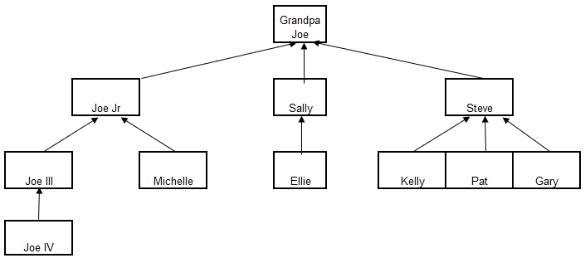
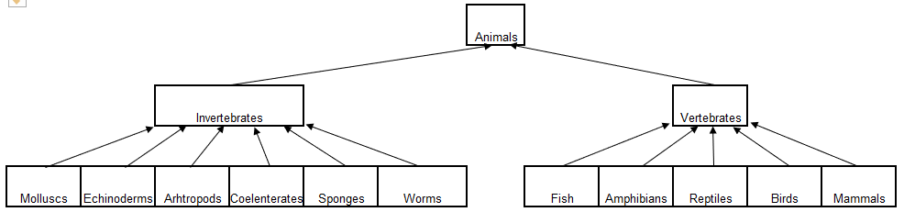

Hierarchies have the following conditions:
- Information can roll up the hierarchy with a many-to-one relationship, but NOT a one-to-many. For example, in the above scenario, Molluscs cannot be both an Invertebrate and a Vertebrate. That would be a one-to-many relationship.
- A hierarchy can be uneven. For example, in the above scenario, Joe III has a child (Joe IV), but his sibling, Michelle, has no kids. Same with Joe III’s cousins Ellie, Kelly, Pat, and Gary.
- Hierarchies can be simple or complex. For example, in the above scenario Steve has three kids, but Sally only has one. A parent can have one child or many.
- Hierarchies can be as deep or as shallow as needed. Depth depends on the content/data going into the hierarchy and whether there is a need to go down to a very granular level or not. In the above scenario, any of the animal types on the third level could be further broken down. For example, reptiles could be further broken down into crocodiles, lizards, snakes, turtles, etc and then snakes could be further broken down as well, if necessary.
Once a hierarchy is built out, Luma will allow a user to run reports at any level within a hierarchy. This is the true power of hierarchies. In the above scenario, a user could generate a report of all animals, all invertebrates, or all Mulloscs. They could also group some of these categories together. For example, a user could run a report of all fish and amphibians, or all of the data associated with Sally and Steve.

