**State of Idaho**

**Luma Project**

**Chart of Accounts Design**

**Deliverable No**. **20**

March 13, 2020



Document Control Information

Document Information

|  |  |
| --- | --- |
| Document Identification | DEL – 020 |
| Document Name | Chart of Accounts Design |
| Project Name | Luma |
| Client | State of Idaho, Office of the State Controller |
| Document Author | Brent Stigler |
| Document Version | 1.0 |
| Document Status | Final |
| Date Released | February 25, 2020 |
| File Name | Deliverable_020_Chart of Accounts Design_Final.docx |

Document Edit History

| Version | Date | Additions/Modifications | Prepared/Revised by |
| --- | --- | --- | --- |
| 1 | 2/25/2020 | Final | Brent Stigler |
|  |  |  |  |
|  |  |  |  |
|  |  |  |  |

Document Review/Approval History

| Date | Name | Organization/Title | Comments |
| --- | --- | --- | --- |
|  |  |  |  |
|  |  |  |  |
|  |  |  |  |

Distribution of Final Document

The following people are designated recipients of the final version of this document:

| Name | Organization/Title |
| --- | --- |
|  |  |
|  |  |
|  |  |

Table of Contents

1 Introduction 4

1.1 Deliverable Description 4

1.2 Purpose 4

1.3 Methodology Approach 4

1.4 Intended Use of Deliverable 4

2 Overview of the Chart of Accounts Development Process 5

2.1 COA Workgroup Charter 5

2.2 COA Redesign Timeline 5

2.3 COA Redesign Methodology 7

2.4 COA Redesign Review and Approval 8

3 Chart of Accounts Design 10

3.1 Agency 10

3.2 Project 11

3.3 Organizational Unit 12

3.4 Fund 14

3.5 Program 17

3.6 Account 18

3.7 Location 20

3.8 Additional Reporting 21

3.9 Appropriation 22

3.10 Funding Source 23

4 Appendices 25

4.1 Sample Agencies Proposed COA Strings and Sample Crosswalks 25

4.2 Key Luma Terminology 27

4.3 Dimension Code Elements 27

# Introduction

## Deliverable Description

This Chart of Accounts (COA) Design deliverable document includes an introduction section describing the purpose, methodology approach, and intended use of this deliverable as specified in Deliverable Expectation Document (DED) 20, Chart of Accounts Design.

Following this introduction section is an Overview of the Chart of Accounts Development Process. The overview describes in greater detail the guiding principles of the Chart of Accounts Charter, the design timeline, the development methodology employed by the Luma Finance team, and reviews of the Chart of Accounts design work by oversight bodies.

Section 3 contains an in-depth discussion of each COA proposed dimension which includes the dimension definition (purpose), purpose rationale, structure, and structure rationale.

The document concludes with various appendices, including proposed COA accounting strings, sample crosswalks from the legacy Statewide Accounting and Reporting System (STARS) to the new COA design, and key Luma terminology as well as an at-a-glance grid summarizing the structural information contained in Section 3.

Refer to the PowerPoint presentation titled *Deliverable_020_Chart of Accounts Design Final.pptx* for additional information regarding the Luma COA design.

## Purpose

The purpose of this document, as stated in DED No. 20, is to define the new State of Idaho Chart of Accounts (the underlying financial and management reporting structure for Luma), provide high-level mapping to STARS, propose naming conventions, and set up a roadmap for transitioning to Luma.

## Methodology Approach

The methodology described in this deliverable provides the reader with a sense of the extensive work that went into the COA redesign process and shed light on the discussions, considerations, and rationale that went into the final COA dimension structure. When relevant, the document includes details where decision points led to a COA Redesign Workgroup decision or software limitations drove an outcome.

## Intended Use of Deliverable

This deliverable provides reasonable assurance to decision-makers and stakeholders that the methodology employed by the COA Redesign Workgroup was sound and that adequate consideration was given to issues that may impact the State of Idaho and its ability to conduct business, meet its reporting obligations, and provide meaningful information to internal and external stakeholders.

The intended audiences for this deliverable are:

* Project Management Office.
* Luma Functional Teams (Budget, Finance, Procurement, Human Resources, and Payroll).
* Luma Technical Team Leads (CSC).
* Division of Statewide Accounting.
* Fiscal Policy Advisory Committee.
* Luma Governance Board.
* State Financial Management Stakeholders.

# Overview of the Chart of Accounts Development Process

## COA Workgroup Charter

**State of Idaho Chart of Accounts Redesign Project**

The State of Idaho, in preparation for the implementation of its next-generation ERP system (Luma) has chosen to redesign its Chart of Accounts (COA). Redesigning Idaho’s Chart of Accounts is one of the most strategically important actions the State will take in preparing the groundwork for Luma. The redesign of the Chart of Accounts will be based on leading practices in government and business. In addition, the new Chart of Accounts will be designed in advance of the implementation of Luma to help ensure that it, first and foremost, serves Idaho’s strategic purposes. Beginning the redesign of the COA before the implementation of the Luma system will help to make sure the implementation is completed in a timely manner.

Idaho’s Chart of Accounts redesign project seeks to:

* Emphasize simplicity, expandability, and flexibility for the life of the system.
* Manage operations and provide services to its citizens.
* Deliver a wide variety of financial and nonfinancial reporting.
* Capture financial data at a meaningful level of detail to assist agencies in managing financial resources.
* Meet the needs of both the State’s central control and operating agencies.

The approach that will be used to develop the new COA design for Idaho will include the following activities.

1. Chart of Accounts Redesign Workgroup - The workgroup will include individuals from multiple State agencies selected by the Luma Project Management Office (PMO) to participate in the workgroup.
2. Survey Key State Agencies - The survey will capture information about the State’s current COA and its actual use by agencies. It will include questions about “pain points” for agencies regarding the existing COA. If necessary, follow up interviews will be conducted with State agencies to gather additional insights about “pain points”.
3. Request Feedback from Selected Software Vendor and Integrator on COA Design Best Practices - Present the software vendor and integrator with information provided by key State agencies and request feedback on the proposed COA design and its compatibility with their products.
4. Develop COA Governance Model and Maintenance Process - A new COA governance model and maintenance process will be developed and reviewed by the Luma Governance Board. COA review considerations include: standardization, consistency of use across agencies, alignment with industry best practices, and flexibility to meet agency requirements.
5. Develop Final COA Design Report - The final COA design report will present the redesigned COA structural elements and governance approach proposed by the State. Additionally, it will include an overview of the rationale of the COA development.

## COA Redesign Timeline

Timeline Overview: 2014 to July 2019

In 2014, recognizing the risks associated with Idaho’s aging business systems, the State of Idaho, Office of the State Controller (SCO) embarked on a journey to replace its legacy Employee Information System (EIS) and Statewide Accounting and Reporting System (STARS), with a new system known as Luma. Over the next five years, through an extensive competitive bidding process, the State selected Information Services Group (ISG) to serve in an advisory role to the State, Infor CloudSuite as its Enterprise Resource Planning (ERP) software solution, Deloitte Consulting LLP as its software integration vendor, and Sherpa as the budgeting module.

COA Redesign Workgroup Timeline: August 1, 2019 to February 12, 2020

The SCO assembled a team of State employees representing a diverse cross-section of agencies to drive the COA redesign process, the backbone of Luma. This group was named the COA Redesign Workgroup. Between August 2019 and February 2020, the COA Redesign Workgroup met nine times as part of the COA redesign process. Key activities were as follows:

* Kick-off meeting.
  + August 1, 2019.
* Five workshops between November and December 2019. Led by Deloitte, these workshops sought to identify the dimensions of the COA necessary for the State of Idaho to conduct business, to meet its internal and external reporting requirements, and to provide meaningful tracking of financial and non-financial information. Workshops were held on the following dates:
  + November 6, 2019.
  + November 12, 2019.
  + November 19, 2019.
  + November 22, 2019.
  + December 3, 2019.
* One formal presentation to the COA Redesign Workgroup on the proposed COA dimension structure was held on January 16, 2020.
* Two follow-up meetings with the COA Redesign Workgroup were held on the following dates:
  + January 24, 2020.
* February 12, 2020.

The COA Redesign Workgroup comprised representation from the following State agencies:

* Division of Financial Management (DFM).
* Legislative Services Office.
* Office of the State Controller.
* Department of Health and Welfare.
* Department of Transportation.
* State Tax Commission.
* Department of Labor.
* Department of Commerce.
* State Liquor Division.
* Military Division.
* Department of Fish and Game.
* Idaho State Police.
* Department of Correction.
* Department of Juvenile Corrections.
* Department of Lands.
* Correctional Industries.

Luma Finance Team Timeline: August 1, 2019 to February 12, 2020

In addition to the above COA Redesign Workgroup meetings, the Luma Finance team (a subset of the work group assigned to the Luma project full-time) performed additional tasks, assignments, and meetings to advance COA elements development. The Luma Finance team met numerous times between August 1, 2019 and February 12, 2020 to further discuss and define the requirements for the COA redesign.

The Luma Finance Team presented the proposed COA redesign work to the Luma Governance Board on January 28, 2020 with positive feedback.

## COA Redesign Methodology

The Luma Finance team took a multifaceted approach to the COA redesign. Tackling this task from several directions ensured that the Luma Finance team considered not just the State financial reporting impact of the new COA design but also factored in budgetary needs, external/third-party reporting and oversight, end-user and operational considerations, cash management controls, Idaho state statutes, and change impacts. The methodology employed included high-level, policy-focused discussions as well as practical operational exercises. The following is a brief discussion of each of those considerations.

Budgetary Needs

The Idaho legislature appropriates spending authority to State agencies based on a number of factors: program/organizational structure, object (i.e. standard class) and fund. In order to meet these needs, the Luma Finance team incorporated the necessary elements into the COA dimension structure required for State appropriation bill drafting. The COA Redesign Workgroup identified system needs of the new Sherpa budgeting system which will replace the existing budgeting system currently employed by DFM.

External/Third-party Reporting and Oversight

Over one-third of Idaho’s state agencies receive federal funds, which come with external financial and performance reporting requirements. The Luma Finance team incorporated these external reporting requirements into the design elements to provide agencies with the flexibility to meet these obligations. An extra dimension, called ‘Additional Reporting’, was added to allow agencies to track information not currently captured through the State’s financial reporting requirements. The team also considered indirect cost allocation requirements and project set-up needs for these agencies.

End-user and Operational Considerations

The COA dimension order (the order of the dimensions in the account string) is embedded with intelligence aimed to reduce keystrokes and data entry errors. The Luma Finance team and the COA Redesign Workgroup arrived at the dimension order presented in this deliverable based on operational behaviors common to agencies participating in the COA Redesign Workgroup. Luma allows users to set up structural relationships, pairing of COA elements, and defaulting values with downstream dimensions to reduce or eliminate data entry options and errors. The Luma Finance team and COA Redesign Workgroup both agreed that the Project dimension would drive more coding decisions than any other dimension, thus driving the decision to make project information second in the keying order (after the Agency dimension). Dimensions keyed less often due to limited use or defaulting were placed at the end of the dimension order.

Cash Management Controls

Cash management, separate from appropriation control, is of importance to the State of Idaho. In order to meet the control requirements of the State, the Luma Finance team considered multiple options for achieving the objectives of responsible cash management. One hurdle the Finance team had to overcome was the issue of at what level in the fund hierarchy cash needed to be controlled. Some agencies require cash controls at the Subfund posting level (see Section 3 below for further explanation of hierarchical structures), while others require posting at the lowest level with cash controls at a summary level. This presented an issue as cash controls are always placed at the posting level within Luma. After extensive discussion with Infor representatives, a programming solution is being implemented that will meet the needs of the State and resolve this issue.

State Statutes

Discussions surrounding the development of the Organizational Unit dimension focused on Idaho Code Section 67-2402, which drives the organizational structure of the executive branch of Idaho State government (which encompasses most State agencies that will use the new system to meet their financial reporting, human resources and payroll, procurement, and budgetary needs). In order to align agency set-up in the Organizational Unit dimension with Idaho Code Section 67-2402, while providing adequate flexibility to account for agencies that do not perfectly align with the stated structure, the Finance team decided on a hierarchy structure based on Section 67-2402, with additional optional levels for agencies that require them.

Change Impacts

The Luma Finance team examined current use of the STARS system including fields and data elements to ensure current agency needs and system uses were incorporated into or accounted for in the new COA design. The Finance team was careful to suggest changes in numbering or naming only when it made sense (either to accommodate new Luma requirements or to fix system limitations/issues stemming from the legacy STARS system). For example, the team elected to carry forward agency numbers and budget unit coding from the legacy STARS system. However, to overcome the confusion between budget (spending plan) and state appropriation (spending authority), the team elected to change the naming from budget unit to appropriation.

The Finance team discussed current assumptions and how Luma would control spending against appropriated dollars. For example, some agencies are appropriated by program, while others are appropriated by organizational structure. On the assumption that the Idaho legislature would continue with this practice into the future, the team elected to set up a separate dimension for appropriation so agencies would have the flexibility to tie appropriation controls to either the Program dimension or the Organizational Unit dimension based on their state appropriation bill.

Operational Exercises for Dimension Development

While the COA Redesign Workgroup meetings involved mainly high-level, policy-driven discussions aimed at meeting reporting and statutory requirements, the Luma Finance team focused in on the practical application of the new COA design. The Luma Finance team completed entity-specific exercises to build out agency values in each proposed COA dimension. These exercises helped to further discussion about dimension structure internally as well as with the COA Redesign Workgroup. Through these exercises, the team identified additional information necessary to achieve the State’s operational, reporting, and tracking objectives.

## COA Redesign Review and Approval

The proposed COA design, presented in Section 3 of this document, has gone through and will continue to go through an extensive vetting process to ensure the COA redesign meets the needs of the State of Idaho and its discrete agencies. As of the date of this deliverable document, the COA design has been informally agreed to by the Luma Finance team. It was presented to the COA Redesign Workgroup on January 16, 2020, revised further, and re-presented on January 24, 2020. The Luma Finance team presented the proposed design to the Luma Governance Board on January 28, 2020 and presented a draft version of this deliverable to the Luma Project PMO February 12, 2020. The final COA redesign proposal was presented to the Governance Board for concurrence on February 25, 2020. The Luma Project Manager acting on behalf of the State Controller completed a review and accepted this deliverable on February 25, 2020.

# Chart of Accounts Design

Section 3 provides detailed information about each Chart of Accounts dimension including the purpose and rationale for each dimension as well as key information about the dimension format (keying order, posting level, field length, etc.)

## Agency

Dimension Purpose and Usage

Purpose Definition *Used to identify the state agency.*

Purpose Rationale Within the Luma application, all financial activity is accounted for by individual State agency and then aggregated for financial reporting. The Agency dimension is critical in allowing the State to post and group transactions by state agency. This practice is supported by Idaho Code Titles 1 and 67 which provide for the establishment and structure of the three branches of State government and their further subdivision, comprised of approximately 90 state agencies that will conduct transactions in the new system.

Dimension Format

Format Definitions

Keying Order Placed first in dimension order.

Summary Level There are no summary levels.

Posting Level **Agency**. Required. This dimension has only one level, the posting level, which is a unique 3-digit code used to identify the agency.

Number of Levels One.

Field Length Min Minimum 3 characters: Agency code (INTEGER, 3). Determined by the State Controller’s Office (SCO).

Field Length Max Maximum 3 characters: Agency code (INTEGER, 3). Determined by the State Controller’s Office (SCO).

Format Rationale

Keying Order For most agencies, this field will default and will not be keyed. The Agency dimension is a parent to the Organizational Unit dimension and, therefore, precedes the Organizational Unit dimension in keying order for those agencies that may key transactions for multiple state agencies.

Posting Level There is only one level within the hierarchy. Both reporting and posting happen at the posting level.

Number of Levels/

Number of Children The Agency dimension has a flat hierarchy. There are no additional levels or children.

The COA Redesign Workgroup contemplated adding a summary level above the agency posting level within the hierarchy of this dimension. The summary level would include the three branches (executive, judicial, and legislative) of State government. The purpose of adding a summary level would be to facilitate reporting by the three branches of State government. Due to system limitations within Luma, it is not possible to add hierarchies in this dimension. The workgroup determined that functionality within the application to group State agencies for aggregated reporting would suffice.

Field Length Min/Max The COA Redesign Workgroup contemplated the optimal numbering format for this dimension, discussing the pros and cons of deviating from the 3-digit agency codes used in the legacy STARS system. Using a 2-digit code would limit the system to 89 possible codes (10-99), as the system will not easily accommodate a leading zero. Using 3 digits increases that limit to 899 (100-999). The Finance team determined the need for more than 900 agency codes is highly improbable and did not see a compelling reason to depart from the numbers currently assigned to state agencies.

## Project

Dimension Purpose and Usage

Purpose Definition *Used to capture transactional data on agency-specific activities or efforts usually with a planned end date.*

*May also be used to silo financial activity into a discrete ledger to simplify reconciliation and record-keeping. For example: cost allocation pools, ongoing billings to outside entities for work performed, co-location and rental agreements, etc.*

Purpose Rationale The Project dimension is a powerful tool that can be used by agencies to meet a variety of business needs. In order to take full advantage of the functionality of the system, the COA Redesign Workgroup has elected to define the purpose of this dimension broadly to meet a variety of operational needs across agencies throughout the State. The purpose has been expanded well beyond the traditional “project” (building, capital, software, etc.), and includes a variety of examples to help agencies understand the broad spectrum of uses for which this dimension may be applied.

Dimension Format

Format Definitions

Keying Order Placed second in dimension order.

Summary Level 1 **Project Level 1**.Optional. The highest summary level within the Project dimension is determined by the agency. Agencies may want to use Summary Level 1 to group projects by project type.

Summary Level 2+ **Project Levels 2+**.Optional. Further granularity through hierarchy build-out to be determined by agency on a project by project basis, based on operational necessity.

Posting Level Lowest level of hierarchy. Required if a project is set up. Determined by agency based on operational necessity.

Number of Levels Unlimited. Determined by agency based on set-up needs.

Number of Children Unlimited. Determined by agency based on set-up needs.

Field Length Min Minimum 3 characters: Agency code (INTEGER, 3). Determined by agency based on set-up needs.

Field Length Max Maximum 25 characters: Agency code (INTEGER, 3) plus (ALPHANUMERIC, 22). Determined by agency based on set-up needs.

Format Rationale

Keying Order The Luma application allows for downstream pairing and defaulting when keying transactions. By placing the Project dimension second in the keying order, just after the Agency dimension (which will default in most cases), agencies can pair or default one or more “downstream” dimensions (Organizational Unit, Program, Fund, Account, Location, Additional Reporting, and Funding Source) with an associated project to reduce or eliminate unnecessary keying. This will increase efficiency and reduce errors.

Summary Level 1 Agencies will have the flexibility to build out the Project dimension according to their business needs. Agencies may find it useful to group projects by type or category in order to maintain a system of organization.

Summary Level 2 Agencies will have flexibility to build out their project hierarchies as needed to accomplish reporting requirements. While some projects will be relatively flat (cost pools, for example), other projects may have complex set-ups to track project costs by phase, task, or activity.

Posting Level Reporting may be done at any level within a hierarchy but posting occurs only at the lowest level of any hierarchy within the Luma application.

Number of Levels/

Number of Children Unlimited number of “children” can be created from one “parent” within any level of a project hierarchy. Luma allows users to add unlimited levels within a hierarchy and to create an unlimited number of children from a parent, providing maximum flexibility to agencies to structure their projects as deep and as broad as needed to achieve operational, reporting, and billing needs.

Field Length Min/Max In order to give agencies maximum flexibility in their numbering conventions for projects, while also avoiding the risk of using a project code already in use by another agency, all codes at all levels in the project dimension will start with the 3-digit agency code. In the STARS legacy system, the maximum cumulative number of characters available to agencies in the Grant and Phase or Project Number and Project Phase fields is 8 alphanumeric. The Luma limitation for this dimension is 25 characters. Luma Finance Team discussions led to the conclusion that some agencies may need up to the system max of 25 characters to meet their business needs.

## Organizational Unit

Dimension Purpose and Usage

Purpose Definition *Used to Identify cost center and its place in an agency’s organizational structure.*

Purpose Rationale Organizational structure and associated accounting activity are integral parts of State of Idaho financial reporting and tracking. Idaho Code 67-2402 provides for the internal structure for each department of the executive branch of Idaho state government. For many of these departments, appropriation is tied to organizational structure. Additionally, for these departments, internal spending controls are placed at various levels of the organization, creating the necessity for this dimension from an appropriation standpoint as well as an internal budgeting and cost control perspective.

Dimension Format

Format Definitions

Keying Order Placed third in dimension order.

Summary Level 1 **Division**. Required level.

Summary Level 2 **Bureau**. Required level. If the division does not have further subdivision, this will be a direct roll-up to Division from level below.

Summary Level 3 **Section**. Required level. If the bureau does not have further subdivision, this will be a direct roll-up to Bureau from the level below.

Summary Level 4+ Further subdivision of sections. Optional, as required by agency structure.

Posting Level **Cost Center**. Required. Posting level cost centers may fall anywhere from level 4 or lower, based on number of intermediate levels required by agency hierarchical structure.

Number of Levels Minimum 4 (Division, Bureau, Section, Cost Center); max unlimited. Dependent upon agency organizational structure.

Number of Children Unlimited. Dependent upon agency organizational structure.

Field Length Min Division minimum 1 character (INTEGER, 1), Bureau minimum 2 characters (INTEGER, 2), Section minimum 3 characters (INTEGER, 3), Cost Center minimum 3 characters (INTEGER, 3).

Field Length Max Maximum 15 characters (INTEGER, 15).

Format Rationale

Keying Order Placed third in keying order, right after the Project dimension, as the posting level cost center may be inferred by the project keyed. If not, then keying a cost center may determine another down-stream field through pairing, such as appropriation. Therefore, logic dictates that this dimension come early in the keying order.

Summary Level 1 Per Idaho Code 67-2402, Division is the highest level of executive branch agency internal structures. For many agencies, this ties directly to their annual state appropriation.

Summary Level 2 Per Idaho Code 67-2402, Bureau is the second highest level of executive branch agency internal structures. Bureaus are a further subdivision of Divisions. For some agencies, this ties directly to their annual state appropriation.

Summary Level 3 Per Idaho Code 67-2402, Section is the third highest level of executive branch agency internal structures. Sections are further subdivisions of Bureaus. For some agencies, this may tie directly to their annual state appropriation.

Summary Level 4+ Some agencies may require further subdivision in their organizational structure below Section due to the size and depth of their organization. Allowing for flexibility in Organizational Unit dimension hierarchies below the Section level gives agencies the ability to build out their structures in this dimension. This allows agencies to meet their cost tracking and reporting needs, rather than forcing all agencies into a “one-size fits all” structure.

Posting Level Cost center is the lowest level in the Organizational Unit dimension for all agencies. This builds consistency across all agencies, creates a common vernacular, and encourages consistent reporting within the agency and across agencies.

There is no roll-up logic built into Cost Center level coding to enable reorganizing at the lowest level in an agency without having to renumber cost centers.

Number of Levels A minimum of four levels (Division, Bureau, Section, Cost Center), with an unlimited maximum, maintains compliance and observance of Idaho state statute while providing the flexibility to add additional levels as needed based on agency operational necessity.

Number of Children Unlimited. Based on agency organizational structure.

Field Length Min Minimum 1 (INTEGER, 1) at Division level, with each level adding a place to facilitate roll-up logic in numbering. Cost Center will be a minimum of three places (INTEGER, 3).

Roll-up logic will be built into the hierarchy of this dimension from the highest level (Division) on down to the level before Cost Center to facilitate efficient report-building at all levels. Cost Center numbers will not include roll-up logic to allow the flexibility within the agency to move cost centers to different roll-ups when reorganization events take place.

Field Length Max System limits field length to 15 (INTEGER, 15).

## Fund

Dimension Purpose and Usage

Purpose Definition *Used to identify the accounting entity against which a transaction is recorded.*

Purpose Rationale A fund is an accounting entity with a self-balancing set of accounts. Cash and/or other resources together with all related liabilities, obligations, reserves, and equities are recorded in funds. Thus, a fund segregates the monies of the entity according to legal or purpose restrictions. The Idaho Legislature appropriates by Fund or Subfund to meet certain objectives in accordance with laws, special regulations, restrictions, or limitations. Statewide Comprehensive Annual Financial Reports (CAFR) are organized by fund type, fund subtype, and fund.

The Luma application uses the Fund dimension when posting financial transactions to check cash balance for payment processing. Cash balance (or unused line of credit balances) must be in excess of the payment amount processed in order to proceed, as this is an indication of sufficient cash to cover the expenditure.

Dimension Format

Format Definitions

Keying Order Placed fourth in dimension order.

Summary Level 1 **Fund Type** (governmental, proprietary, and fiduciary). Determined by and set-up through COA governance process).

Summary Level 2 **Fund Subtype** (general fund, special revenue fund, enterprise fund, internal service fund, investment fund, pension fund, etc.). Determined by and set-up through COA governance process.

Summary Level 3 **Fund**.Determined by and set-up through COA governance process.

Posting Level **Subfund**. Determined by and set-up through COA governance process.

Number of Levels 4 levels within this dimension.

Number of Children Unlimited. Determined by and set-up through COA governance process.

Field Length Min/Max: Summary Level 1 - *Fund Type* (ALPHA, 1). Governmental: G, Proprietary: P, Fiduciary: F.

Summary Level 2 - *Fund Subtype* (ALPHA, 3). Governmental: GEN (General Fund), GIE (Income Funds), Proprietary: IGI (Group Insurance Acct), IRM (Retained Risk Acct), Fiduciary: FAC (Custodial Funds), FAP (Payroll Clearing).

Summary Level 3 - *Fund* (INTEGER, 3), no leading zeroes.

Posting Level 4 - *Subfund* (INTEGER, 5). Fund + (INTEGER, 2).

As of the final deliverable date, the COA Redesign Workgroup had agreed to the numbering described above and below for this dimension. However, final nomenclature will be determined during the build out process.

Subfund numbering will generally be based on legacy STARS numbering, with the following modifications: the first leading zero will be dropped, funds with more than one leading zero will be renumbered, and funds with no Subfund will be succeeded by ‘00’, as follows:

|  |  |  |
| --- | --- | --- |
| **Fund (Legacy STARS System)** | **Fund Detail (Legacy STARS System)** | **Subfund (Luma Application)** |
| 0348 | 02 | 34802* |
| 0401 | no fund detail | 40100 |
| 0050 | 03 | 10503 |

*For SCO and CAFR reporting purposes, Fund and Subfund will be preceded by a leading one when the Fund pertains to an outside entity (non-State agency). For example: 134802 instead of 34802.

Format Rationale

Keying Order Luma allows for downstream pairing and defaulting when keying transactions. By placing the Fund dimension fourth in the keying order, agencies will be able to pair or default one or more “downstream” dimensions (Program, Account, Location, Additional Reporting, Appropriation, and/or Funding Source) to reduce or eliminate unnecessary keying. This will increase efficiency and reduce errors.

Summary Level 1 CAFR reporting is done at the Fund Type level. Decision to build Fund Type into the hierarchy was made to facilitate CAFR reporting requirements.

Summary Level 2 CAFR reporting is done at the Fund Subtype level. Decision to build Fund Subtype into the hierarchy was made to facilitate CAFR reporting requirements.

Summary Level 3 Fund: The Idaho Legislature may appropriate to agencies at the Fund level to meet certain objectives in accordance with laws, special regulations, restrictions, or limitations.

Posting Level Subfund: The Idaho Legislature may appropriate to agencies at the Subfund level. Reporting may be done at any level within a hierarchy but posting occurs at the lowest level of any hierarchy within the Luma application.

A possible exception to the Subfund Posting level: Fish and Game may have one Subfund that is not the posting level. The posting level is one level below Subfund to accommodate a unique set of circumstances pertaining to that agency.

Number of Levels/

Number of Children There are 4 levels to the Fund dimension. Summary levels 1 and 2 (Fund Type and Fund Subtype) are dictated by Governmental Accounting Standards Board (GASB) requirements for CAFR reporting. Summary level 3 (Fund) and the posting level (Subfund) may have an unlimited number of “children” based on the needs of the State, as determined by SCO/DFM in conjunction with Idaho state statute.

Field Length Min/Max The COA Redesign Workgroup initially determined there was no compelling reason to make sweeping changes to the fund numbering system in the legacy STARS system.

The decision to drop the leading 0 (zero) on the fund number was prompted by Luma’s Spreadsheet Designer, an Excel add-on tool used to upload and download large datasets to and from the application’s database. Excel drops leading zeros unless the cell is formatted as text. Fund and Subfund (legacy STARS Fund and Fund Detail) were combined at the posting level to create unique posting codes for each Subfund. Since each dimension only has one keying field, both legacy STARS Fund and Fund Detail are required in one entry.

Fund numbers starting with more than one 0 (zero) will be renumbered through the COA governance process.

## Program

Dimension Purpose and Usage

Purpose Definition *Used to identify ongoing agency activities or functions that occur across the organizational structure.*

Purpose Rationale The Program dimension provides agencies with the ability to define each of their major programs or functions and track financial activity accordingly. For agencies that are appropriated by program rather than organizational structure, this dimension will be used to pair with the Appropriation dimension to put proper appropriation/spending controls in place at the agency.

Dimension Format

Format Definitions

Keying Order Placed fifth in dimension order.

Summary Level 1+ **Program Level 1**. Optional. The highest summary level within the Program dimension.

Posting Level Lowest level of hierarchy. Hierarchy may be flat in this dimension with no summary levels above posting level. Determined by agency based on set-up needs.

Number of Levels Unlimited. Determined by agency based on set-up needs.

Number of Children Unlimited. Determined by agency based on set-up needs.

Field Length Min Minimum 3 characters: Agency code (INTEGER, 3). Determined by agency based on set-up needs.

Field Length Max Maximum 15 characters: Agency code (INTEGER, 3) plus (ALPHANUMERIC,12). Determined by agency based on set-up needs.

Format Rationale

Keying Order Luma allows for downstream pairing and defaulting when keying transactions. By placing the Program dimension fifth in the keying order, agencies will be able to pair or default an “upstream” dimension (Project, Organizational Unit, Fund) to a program. Further, agencies will have the ability to pair a downstream dimension with a program. This will reduce or eliminate unnecessary keying, increase efficiency, and reduce data entry errors.

Summary Level 1+ For agencies that utilize the Program dimension, set-up will be unique and depend upon the specific agency’s program structure. The number of levels in the hierarchy will depend on the agency’s program structure and reporting needs.

Posting Level Reporting may be done at any level within a hierarchy but posting occurs only at the lowest level of any hierarchy within the Luma application. Posting level will depend on program structure and reporting needs of the agency.

Number of Levels/

Number of Children An unlimited number of “children” can be created from one “parent” within any level of a program hierarchy. Luma’s ability to allow users to add unlimited levels within a hierarchy and to create an unlimited number of children from a parent provides maximum flexibility for agencies to structure Program dimension hierarchies as deep and as broad as needed to achieve operational and reporting needs.

Field Length Min/Max In order to give agencies maximum flexibility in their numbering conventions for their programs, while also avoiding the risk of using a program code already in use by another agency, all codes at all levels in the Program dimension will start with the 3-digit agency code.

In the legacy STARS system, there are 6 fields dedicated to Program tracking: function, activity, program, element, Program Cost Account (PCA), and PCA level 1. Agencies use one or more of these program elements, with only one agency making use of the PCA level 1 field. Some agencies use the fields redundantly, and some use a field for some purpose not directly related to program (location, for example). Through well-designed Program dimension hierarchies in conjunction with other dimensions, agency code plus up to 12 alphanumeric places should give agencies flexibility to meet their reporting requirements.

## Account

Dimension Purpose and Usage

Purpose Definition *Used to capture the category of all transactions that affect the balance sheet, statement of revenues, expenditures, and changes in fund balance, and other financial statements.*

Purpose Rationale Balance sheet accounts, expenditure and revenue objects, and other accounts needed for financial reporting have been incorporated into one comprehensive list of accounts to create a cohesive, numbered system of accounts.

Dimension Format

Format Definitions

Keying Order Placed sixth in dimension order.

Summary Level 1 **Account Type**. Assets, Liabilities, Fund Balance, Revenues, Expenditures, Statistics and Other Uses.

Summary Level 2 **Account Category**.Further breakdown of Account Types (for example assets: current, non-current; liabilities: long-term, other; expenditures: personnel costs, operating expenditures, capital outlay, and trustee and benefit payments).

Summary Level 3 **Summary Account**.Further breakdown of Account Category (for example personnel: salary, benefits; operating: communications, professional services).

Summary Level 4 **Account**.Additional detail for Summary Accounts (for example salary: employees, student, shift differential).

Posting Level **Posting Account**.For many accounts the posting level and the Account level are the same. Posting account may be a further breakdown of an Account, where additional detail is required.

Number of Levels 5 levels. Determined by SCO to meet CAFR and other State reporting requirements, in conjunction with the reporting requirements of State agencies.

Number of Children As needed for standardization. To be determined by SCO to meet CAFR and other State reporting requirements, in conjunction with the reporting requirements of State agencies.

Field Length Min/Max Account type, account category and summary account (ALPHANUMERIC 15), account (INTEGER, 4), posting account (INTEGER, 6), all determined by SCO.

Format Rationale

Keying Order Required field that will need to be keyed in most instances. Placed after other dimensions that may pair with the Account dimension to limit available posting selections. For example, a project may be paired with the Account dimension to allow only personnel or operating expenditure types.

Summary Level 1 Account Type. Highest level of account groupings to allow more detailed breakout of account types to be organized into a logical order.

Summary Level 2 Account Category. Critical grouping level necessary for financial reporting and appropriation spending controls.

Summary Level 3 Summary Account. Additional detail for tracking spending and to add transparency in cost types. Another critical level of account grouping for financial reporting.

Summary Level 4 Account. Typical account breakdown used in tracking costs, revenues, assets, and liabilities by more specific name to provide end users with adequate descriptions to pick the correct account so that proper financial reporting occurs.

Posting Level Posting Account. In many cases, posting level and Summary Level 4 are the same. In cases where agencies require more detail than provided by summary level 4, multiple posting level posting accounts will roll up to an account. Agencies that require this additional detail for external reporting and tracking purposes can employ the COA data governance process to request additional posting accounts for a given account.

Number of Levels/

Number of Children Determined by SCO. Five levels are adequate to provide the various levels of detail needed for effective financial reporting while providing agencies with the level of detail necessary to meet their agency-specific reporting requirements. Accounts needed in this dimension are driven by financial and external/third-party reporting requirements.

Field Length Min/Max Naming and numbering convention determined by SCO. Posting level of 6 characters was deemed most efficient to allow the State enough positions to number all necessary posting accounts while grouping them into a logical numbering system that mirrors other public and private accounting structures.

## Location

Dimension Purpose and Usage

Purpose Definition *Used to record transactions to a specific geographic position.*

Purpose Rationale The Location dimension exists to capture location information on a transactional level. A location may be an office or building, a city, county, other jurisdiction, or other physical location.

Dimension Format

Format Definitions

Keying Order Placed seventh in dimension order.

Summary Level 1+ Dimension is optional. Agencies may request to build hierarchies in the Location dimension through the established COA data governance process.

Posting Level **Location**.Lowest level of hierarchy.

Number of Levels Unlimited.

Number of Children Unlimited.

Field Length Min Minimum 3 characters: Agency code (INTEGER, 3). Determined by agency based on set-up needs.

Field Length Max Maximum 15 characters: Agency code (INTEGER, 3) plus (ALPHANUMERIC, 12). Determined by agency based on set-up needs.

Format Rationale

Keying Order Placed lower in the keying sequence as not all agencies will make use of the dimension. For the agencies that do, not all transactions may require a location.

Summary Level 1+ Agencies that elect to utilize the Location dimension may build hierarchies that meet their business needs. Agencies will utilize the COA data governance process to request new location hierarchies.

Posting Level Agencies that elect to utilize the Location dimension may build hierarchies that meet their business needs. There is no preset level for the posting level in this hierarchy. Agencies will utilize the COA data governance process to request new posting locations.

Number of Levels/

Number of Children Agencies that elect to utilize the Location dimension may build hierarchies that meet their business needs.

Field Length Min/Max In order to give agencies maximum flexibility in their numbering conventions for their locations, while also avoiding the risk of using a location code already in use by another agency, all codes at all levels in the Location dimension will start with the 3-digit agency code.

## Additional Reporting

Dimension Purpose and Usage

Purpose Definition *Used to code and track items based on agency-specific reporting needs.*

Purpose Rationale This dimension is optional and can be used for agency-specific reporting and tracking requirements on activities that may cross several projects, programs, appropriations, organizational units, or locations.

Dimension Format

Format Definitions

Keying Order Placed eighth in dimension order.

Summary Level 1+ Dimension is optional. Summary levels are optional. Agencies may request to build hierarchies in the Additional Reporting dimension through the established COA data governance process.

Posting Level Lowest level of hierarchy. Posting happens at the lowest level of any hierarchy within Luma.

Number of Levels Unlimited. To be determined at the agency level based on agency needs.

Number of Children Unlimited. To be determined at the agency level based on

agency needs.

Field Length Min Minimum 3 characters: Agency code (INTEGER, 3). Determined by agency based on set-up needs.

Field Length Max Maximum 15 characters: Agency code (INTEGER, 3) plus (ALPHANUMERIC, 12). Determined by agency based on set-up needs.

Format Rationale

Keying Order Not all agencies will employ the use of the Additional Reporting dimension. For those that do, additional reporting may be triggered by an upstream keying event in one of the other dimensions. Luma allows for downstream pairing and defaulting when keying transactions. By placing the Additional Reporting dimension in the eighth position, agencies will be able to use this dimension for agency specific activity tracking and reporting with “upstream” dimensions (Project, Fund, Program, Account).

Summary Level 1+ To be determined at the agency level based on operational needs. Summary levels within the Additional Reporting dimension are optional. If not needed, agencies can request a posting level item with no hierarchical roll-up.

Posting Level Reporting may be done at any level within a hierarchy but posting happens at the lowest level of any hierarchy within the Luma application.

Number of Levels/

Number of Children Unlimited number of “children” can be created from one “parent” within any level of the Additional Reporting hierarchy. Luma’s ability to allow users to add unlimited levels within a hierarchy and to create an unlimited number of children from a parent provides maximum flexibility to agencies to structure the Additional Reporting dimension as deep and as broad as needed to achieve operational, reporting, and billing needs.

Field Length Min/Max In order to give agencies maximum flexibility in their numbering conventions for their additional reporting elements, while also avoiding the risk of using an additional reporting code already in use by another agency, all codes at all levels in the Additional Reporting dimension will start with the 3-digit agency code.

## Appropriation

Dimension Purpose and Usage

Purpose Definition *Used to identify a program or segment of an agency for which the legislature has set spending controls. Agency appropriations align with specific state goals and performance objectives.*

Purpose Rationale Stand-alone dimension that can be paired with the Organizational Unit or Program dimension to set appropriation and spending controls for agencies based on their annual appropriation bill.

Dimension Format

Format Definitions

Keying Order Placed ninth in dimension order.

Summary Level 1 **State Goal**.Required.

Summary Level 2 **State Objective**.Required.

Posting Level **Appropriation**.Required.

Number of Levels 3 levels.

Number of Children Many.

Field Length Min/Max State Goal (INTEGER, 2); State Objective (INTEGER, 2); Appropriation (ALPHA, 4).

Format Rationale

Keying Order Placed near end of keying order, as appropriation will typically be triggered by another dimension element upstream in the keying order. Staff will rarely need to manually enter an appropriation.

Summary Level 1 State Goal is used in statewide reporting.

Summary Level 2 State Objective is used in statewide reporting.

Posting Level Appropriation code ties directly to State appropriation as set by the legislature. Used to exert spending limits by program or organizational structure, fund, and account type (specifically expenditure types).

Number of Levels/

Number of Children Determined by SCO/DFM to meet financial and performance reporting needs.

Field Length Min/Max Coding determined by SCO/DFM.

## Funding Source

Dimension Purpose and Usage

Purpose Definition *Used in conjunction with the Project dimension to indicate the source of the money used to fund a project. This could include federal, state, local grants, outside entities billed for a service or project, private grants, etc.*

Purpose Rationale The Funding Source dimension provides agencies with the ability to connect a project to its associated source of funding. This allows agencies to produce invoices for billing purposes and to summarize transactional data by funding source in order to meet reporting requirements.

Dimension Format

Format Definitions

Keying Order Placed last in Dimension order.

Summary Level 1 **Type of Funding Source**. The highest summary level within the Funding Source dimension will be the Type of Funding Source. Agencies can pick from a list of pre-defined funding source types (Federal, State, Local, etc.). If funding source type is not listed, agencies can request new funding source type to be added through established COA data governance process (TBD).

Summary Level 2 **Issuing Entity**. Issuing Entity will be the second summary level within the Funding Source dimension. Agencies can pick from a list of predefined issuing entities (US Department of Labor, Health and Human Services, Gates Foundation, etc.) If the issuing entity is not listed, agencies can request new issuing entities to be added through the established COA data governance process.

Posting Level **Funding Source**. Determined by agency based on set-up needs. Agencies will request Funding Source dimension set-up through the established COA data governance process.

Number of Levels There are three levels to the Funding Source dimension.

Number of Children Unlimited. Determined by agency based on set-up needs.

Field Length Min Minimum 1 character (ALPHANUMERIC, 1).

Field Length Max Maximum 15 characters (ALPHANUMERIC, 25).

Format Rationale

Keying Order Luma allows for downstream pairing and defaulting when keying transactions. A funding source will always have one or more projects linked to it, but there may be projects that do not have a funding source (for example, those being used for allocations). By placing Funding Source last in the keying order, agencies will be able to pair or default the Project dimension with a Funding Source, when applicable, to reduce or eliminate unnecessary keying. This will increase efficiency and reduce errors.

Summary Level 1 Type of Funding Source:

* Federal Grant.
* State Grant.
* Local Grant.
* Private, Not-for-profit.
* Private, For-profit, etc.

Summary Level 2 Issuing Entity - entities will be grouped by Funding Source and numbering conventions will align accordingly.

Posting Level Funding Source is the lowest level in the Funding Source dimension for all agencies. This builds consistency across all agencies, creates a common vernacular, and encourages consistent reporting within the agency and across agencies.

Number of Levels/

Number of Children There are 3 levels to the Funding Source dimension with an unlimited number of “children” that can be created at the posting level to fit agency needs.

Field Length Min/Max In order to give agencies maximum flexibility in their numbering conventions for funding source, while also avoiding the risk of using a Funding Source code already in use by another agency, all codes at the posting level in the Funding Source dimension can be up to 25 alphanumeric characters.

# Appendices

## Sample Agencies Proposed COA Strings and Sample Crosswalks

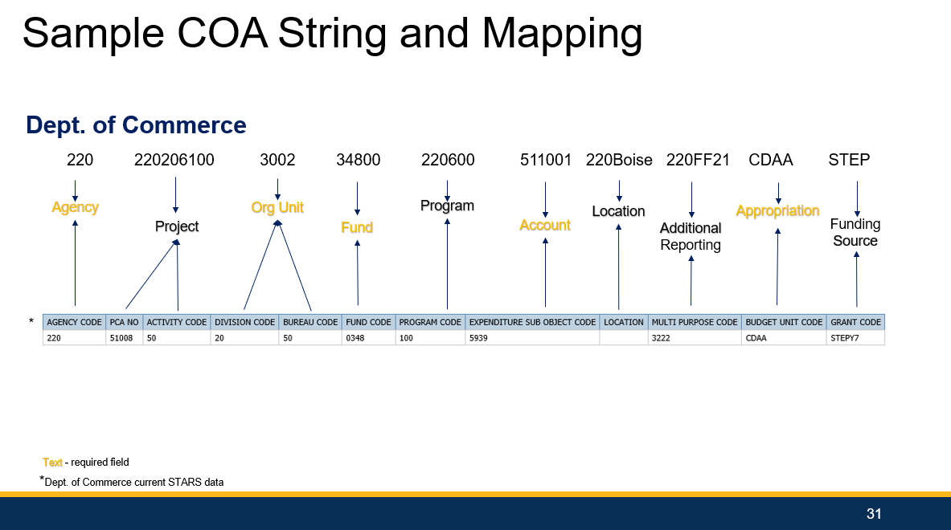

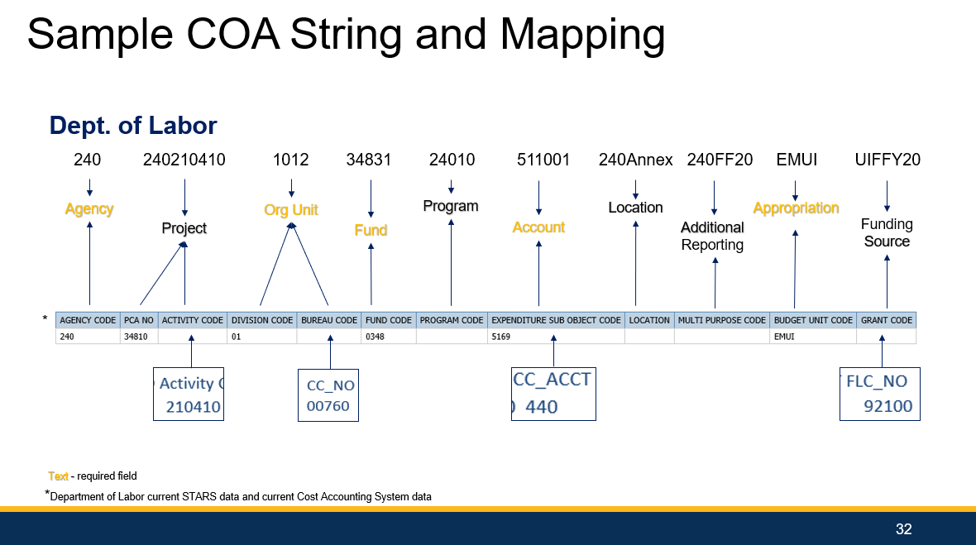

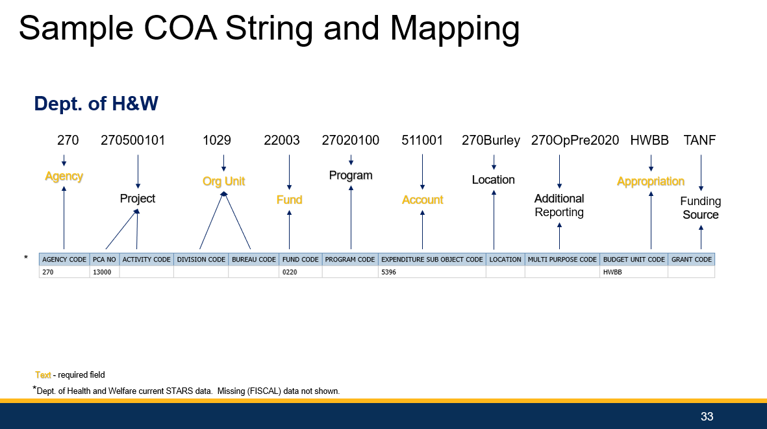

## Key Luma Terminology

| **Term** | **Definition** |
| --- | --- |
| **Chart of Accounts** | A Chart of Accounts (COA) is used by an organization to define each class of items for which funds are spent or received. It is the basic and the most important building block for any finance organization. A well-designed COA increases business value, enhances internal controls, reduces costs, increases efficiency, and improves customer service. |
| **Dimension** | A dimension represents a “bucket” of values available to represent and record each accounting entry. Effective segmentation allows for ease in addressing reporting needs. |
| **Hierarchy** | The hierarchy is the roll-up structure upon which the Chart of Accounts is framed. Typically, a hierarchy consists of a singular entity at the top with subsequent entities underneath. |
| **Ledgers** | All transactions are associated with a ledger. Ledgers can be shared across the reporting basis, except the close ledger and currency ledger that are unique to each reporting basis. The core ledger is created automatically and assigned to the reporting basis. A close ledger is generated automatically for each reporting basis that is created. The ability exists to define other ledgers to meet an organization's reporting requirements. For example, an organization can create adjustment ledgers and eliminating entries ledgers. Ledgers participate in a basis and can be shared by multiple bases. An organization can create an unlimited number of ledgers (for example, budgetary, tax, localized, audit, and operational adjustments). |
| **Reporting Basis** | A reporting basis pulls together the accounting elements required to produce financial reports that adhere to specific accounting standards (such as Generally Accepted Accounting Principles (GAAP), International Finance Reporting Standards (IFRS), or local standards). A reporting basis can also be used to generate internal financial reports that are used by executives to make budgetary, management, and operational assessments. Reports must be in context of a reporting basis to guarantee complete results. The delivered reports within Luma include the reporting basis definition by using a cross reference to the reporting basis dimension found in the Luma Finance Enterprise Group (FEG) cube. FEG includes attributes from the business classes Finance Enterprise Group and Reporting Basis. |
| **Structural Relationships** | Structural relationships create a relationship between dimensions of the Finance Enterprise Group finance structure. Structural relationships can be used to define validation rules for each relation between dimensions and values within that dimension. |

## Dimension Code Elements

| **Dimension** | **Hierarchy** | **Character Length** | **Code Type** | **Centrally or Agency Defined?** |
| --- | --- | --- | --- | --- |
| **Agency** | Agency | 3 | Integer | Centrally |
| **Project** | Project Level 1 Project Level 2 Project Level ∞ | 3-25 4-25 4-25 | Agency + Alphanumeric Agency + Alphanumeric Agency + Alphanumeric | Agency Agency Agency |
| **Organizational Unit** | Division Bureau Section  Level ∞ Cost Center | 1-15 2-15 3-15 4-15  3-15 | Integer Integer Integer Integer  Integer | Agency Agency Agency Agency  Agency |
| **Fund\*** | Fund Type Fund Subtype Fund Subfund | 1 3 3 5 | Alpha Alpha Integer Fund + Integer | Centrally Centrally Centrally Centrally |
| **Program** | Program Level 1 Program Level 2 Program Level ∞ | 3-15 4-15 4-15 | Agency + Alphanumeric Agency + Alphanumeric Agency + Alphanumeric | Agency Agency Agency |
| **Account** | Account Type Account Category Summary Account Account Posting Account | 15 15 15 4 6 | Alphanumeric Alphanumeric Alphanumeric Integer Integer | Centrally Centrally Centrally Centrally Centrally |
| **Location** | Location (may be flat or have levels) | 3-15 | Agency + Alphanumeric | Agency |
| **Additional Reporting** | Additional Reporting (may be flat or have levels) | 3-15 | Agency + Alphanumeric | Agency |
| **Appropriation** | State Goal State Objective Appropriation | 2 2 4 | Integer Integer Alpha | Centrally Centrally Centrally |
| **Funding Source** | Type of Funding Source Issuing Entity Funding Source | 1-25 1-25 1-25 | Alphanumeric Alphanumeric Alphanumeric | Centrally Centrally Agency |

*Final nomenclature for the Fund dimension to be determined during the build-out process.